A Project Report on

**Football Fixture Association**

By

**Prathmesh More**

**Rishi Ram**

MCA – I, SEM – II

2023-24

To

Savitribai Phule Pune University, Pune

In Partial Fulfillment of the Degree of

Master in Computer Application (M. C. A.)

Under The Guidance Of

**Prof. Bhavana Magar**

|  |
| --- |
| **Suryadatta Group of Institutes, Pune** |
| |  | | --- | | **Suryadatta Institute of Management and Mass Communication (SIMMC)** | |

Date:- 25-04-2024

**CERTIFICATE**

This is to certify that Mr. Prathmesh More & Rishi .P. Ram, has successfully completed his project work entitled. **Football Fixture Association** in partial fulfillment of MCA – I Semester-II program for the year A.Y. 2023 -2024. He have worked under our guidance and direction.

**Prof. Bhavana Magar Dr. Manisha Kumbhar**

**Project Guide HOD-MCA,SGI**

**Examiner 1 Examiner 2**

**Date : 25-04-2024**

**Place : Pune**

**Acknowledgment**

We are the student of MCA first year. Here by we express our thanks to our project guide for allowing us to do the project on Football Fixture Association. This project work has been the most exciting part of our learning experience which would be an asset for our future carrier. We would especially like to thank our guide and mentor Prof. Bhavana Magar , who constantly guided us in developing, pushing us to search for more answers to her numerous questions. Also I would like to thank Dr. Rupali Dahake , project coordinators for her support. As a building block of MCA Department, I thank Dr. Manisha Kumbhar, HOD, MCA Department for her continuous support and help. We are grateful to many classmates who contributed their suggestions. Their hard work and examples push us to limits of our capability and encourage us daily.

**Thank You**

**Student Name :Prathmesh .M. More**

**Roll No. : 20230201025**

**Student Name : Rishi .P. Ram**

**Roll No. : 20230201032**

**Index**

|  |  |
| --- | --- |
| **Chapter** | **Page number** |
| **CHAPTER 1 : INTRODUCTION** | |
| 1.1 Existing System | **7** |
| 1.2 Need for System | **8** |
| 1.3 Operating Environment Hardware and Software | **9** |
| 1.4 Brief Description about Technology Used | **11** |
| **CHAPTER 2 : PROPOSED SYSTEM** | |
| 2.1 Proposed System (Introduction of system) | **13** |
| 2.2 Module specifications (Scope) | **14** |
| 2.3 Objectives of System | **16** |
| **CHAPTER 3 : ANALYSIS & DESIGN** | |
| 3.1 Use Case Diagrams | **18** |
| 3.2 Activity Diagram | **24** |
| 3.3. Sequence Diagram | **29** |
| 3.4 Class Diagram | **33** |
| 3.5 ER Diagram | **34** |
| 3.6 Module Hierarchy Diagram | **35** |
| 3.7 Table specifications (Database design) | **36** |
| 3.8 Data dictionary | **39** |
| **CHAPTER 4 : USER MANUAL** | |
| 4.1 User Interface Screens (Input) | **43** |
| 4.2 Output Screens with data | **50** |
| 4.3 Data Reports | **56** |
| 4.4 Sample program code | **57** |
| 4.5 Limitations | **75** |
| 4.6 Conclusion | **77** |
| 4.7 Bibliography | **78** |

**CHAPTER 1: INTRODUCTION**

In today's digital age, the world of sports enthusiasts and football fans alike seek more than just match schedules and results. They crave a comprehensive experience that seamlessly blends fixture information with opportunities to engage further with their favorite teams and players. This demand has spurred the evolution of platforms that integrate football fixtures with e-commerce functionality, offering fans a one-stop destination for both information and merchandise.

This project aims to explore existing systems that successfully merge football fixtures with e-commerce, providing users with a holistic experience that caters to their passion for the sport. By examining established platforms, we can gain insights into how fixture information is coupled with opportunities to purchase merchandise and other related products, thereby enhancing user engagement and monetization potential.

Through this exploration, we seek to understand the intricacies of combining fixture data with e-commerce features, identify key players in the industry, and draw inspiration for potential innovations or enhancements in this space. By leveraging existing systems as benchmarks, we aim to develop a deeper understanding of user expectations and preferences, guiding the creation of future projects that deliver value to football enthusiasts worldwide.

At the heart of our website lies the spirit of the beautiful game. We're dedicated to providing you with an immersive experience that celebrates the excitement, drama, and camaraderie that football brings to millions of fans worldwide.

**Here's what you can expect from our platform:**

Comprehensive Fixtures: Stay up-to-date with the latest football fixtures, including matches from top leagues, international tournaments, and prestigious cups. Whether it's the FIFA World Cup, UEFA Champions League, Premier League, or La Liga, we have all the information you need to plan your football viewing schedule.

Detailed Match Coverage: Dive into match previews, live updates, and post-match analysis for a deeper understanding of the game. From key player performances to tactical insights, we provide comprehensive coverage to enhance your football experience.

Player Profiles: Get to know your favorite football stars with detailed player profiles. From their career statistics to personal achievements, our player profiles offer a glimpse into the lives of football's biggest icons.

E-commerce Store: Elevate your football fandom with our e-commerce store, where you'll find a wide range of football merchandise, apparel, and accessories. Whether you're looking for team jerseys, football boots, or collectible memorabilia, our store has something for every fan.

**1.1 Existing System**

* **Official Club Websites:**

Many football clubs have their own official websites where they sell merchandise and provide fixture information.

Examples include the websites of major clubs like Manchester United, FC Barcelona, Real Madrid, etc.

* **Sports Merchandise Marketplaces:**

Platforms like Fanatics, Nike, and Adidas offer a wide range of sports merchandise, including football jerseys, apparel, and accessories.

While they may not provide fixture information directly, you can find football-related products for sale.

* **Sports Apparel Retailers:**

Retailers specializing in sports apparel and equipment, such as JD Sports, Decathlon, and Sports Direct, often sell football-related merchandise.

While they may not focus specifically on fixture information, you can find products related to football teams and players.

* **Sports Streaming Services:**

Platforms like ESPN+ and DAZN offer live streaming of football matches, along with access to related content and merchandise.

While primarily focused on broadcasting matches, they may also offer merchandise for sale.

**1.2 Need for System**

1. **Comprehensive User Experience:**

Fans of football are not only interested in match schedules but also seek opportunities to engage further with their favorite teams and players. By combining fixture information with e-commerce features, a platform can provide users with a comprehensive experience that caters to their passion for the sport.

1. **Convenience:**

Having access to both fixture information and the ability to purchase merchandise in one place offers convenience for fans. They can plan their engagement with upcoming matches while also having the option to support their teams through merchandise purchases or attendance at games.

1. **Monetization Opportunities:**

Integrating e-commerce functionality into a football fixtures platform opens up avenues for monetization. By selling merchandise, and other related products, the platform can generate revenue through transactions and partnerships with clubs, brands, and sponsors.

1. **Enhanced Fan Engagement:**

Providing fans with the opportunity to purchase merchandise directly from the fixture platform enhances fan engagement. It allows fans to interact with their favorite teams beyond match attendance or viewing, fostering a deeper connection and sense of loyalty.

1. **Data-driven Insights:**

A system that combines fixture information with e-commerce functionality can gather valuable data on user preferences, purchasing behavior, and engagement patterns. This data can be leveraged to personalize recommendations, improve user experience, and drive targeted marketing efforts.

**1.3 Operating Environment Hardware and Software**

* **Hardware Requirement**

|  |  |
| --- | --- |
| **Required field** | **Expected response from students with options** |
| **Processor (CPU):** | Intel Core i3/i5 or equivalent |
| **Operating System:** | Microsoft Windows 10 Professional x64 |
| **Memory:** | 4 GB RAM & Above |
| **Storage:** | 512 GB HDD or 256 GB HDD |
| **Monitor/Display:** | 18" LCD monitor, resolution of 1600 x 900 or better. |

* **Software Requirement**

|  |  |
| --- | --- |
| **Software Requirements** | |
| **Required field** | **Expected response from students with options** |
| **Operating System** | Windows 7 and above |
| **User Interface** | HTML, Bootstrap |
| **Browser** | Google Chrome, Mozilla Firefox,  Internet Explorer |
| **Database** | MySQL |
| **Front End** | HTML, CSS |
| **Editor** | Visual Studio Code |
| **Programming Languages/Technology** | HTML, CSS, PHP, |
| **Script Languages** | JavaScript |

**1.4 Brief Description About Technologies Used**

1. **HTML (Hypertext Markup Language):**

HTML is the standard markup language used to create and structure web pages.

It defines the structure and content of web pages using a system of tags and attributes.

HTML provides the basic building blocks for creating elements such as headings, paragraphs, lists, links, and images on a web page.

1. **CSS (Cascading Style Sheets):**

CSS is a stylesheet language used to control the presentation and layout of HTML elements on a web page.

It allows developers to define styles such as colors, fonts, spacing, and positioning to enhance the visual appearance of web pages.

CSS can be applied directly within HTML documents or linked externally to separate style sheets, providing greater flexibility and maintainability.

1. **JavaScript:**

JavaScript is a scripting language that enables interactive and dynamic functionality on web pages.

It is primarily used for client-side scripting, allowing developers to manipulate HTML elements, handle events, validate forms, and create animations.

JavaScript can also be used for server-side scripting using platforms like Node.js, enabling developers to build full-stack web applications.

1. **PHP (Hypertext Preprocessor):**

PHP is a server-side scripting language designed for web development.

It is commonly used for building dynamic web pages, processing form data, interacting with databases, and generating content dynamically.

PHP can be embedded directly into HTML or used to create standalone scripts that interact with web servers and databases.

1. **MySQL:**

MySQL is an open-source relational database management system (RDBMS).

It is widely used for storing and managing structured data in databases, particularly in web development environments.

MySQL supports SQL (Structured Query Language) for querying and manipulating data, making it a popular choice for powering dynamic web applications that require data storage and retrieval.

Together, HTML, CSS, JavaScript, PHP, and MySQL form the foundation of modern web development, enabling developers to create dynamic, interactive, and visually appealing web applications that deliver engaging user experiences.

**CHAPTER 2: PROPOSED SYSTEM**

**2.1 Proposed System (Introduction of system)**

Our proposed system aims to create a dynamic and comprehensive platform that seamlessly integrates football fixtures with e-commerce functionalities, catering to the needs and desires of football enthusiasts worldwide. By combining fixture information with opportunities for merchandise purchases and other football-related offerings, our system aims to revolutionize the way fans engage with the sport they love.

Introduction:

Welcome to our innovative system that seamlessly integrates football fixtures with e-commerce functionality, revolutionizing the way fans engage with their favorite teams and matches. In today's digital age, where the passion for football knows no bounds, our platform stands at the forefront, offering a comprehensive and immersive experience that caters to the diverse needs and desires of enthusiasts worldwide.

At its core, our system is designed to provide users with a centralized hub where they can access up-to-date fixture information while exploring a wide array of e-commerce offerings related to the beautiful game. From match schedules to merchandise, and beyond, our platform empowers fans to indulge their passion for football like never before, all within a single, user-friendly interface.

The primary goal of our system is to enhance fan engagement by seamlessly blending fixture data with e-commerce functionalities, thereby creating a dynamic and interactive experience that captivates users from the moment they log in. Whether they're planning their matchday experience, shopping for official merchandise, users can navigate our platform with ease, finding everything they need at their fingertips.

**2.2 Module specifications (Scope)**

**Module Specification:**

Our system will be divided into several modules, each serving a specific function to ensure the seamless integration of football fixtures with e-commerce functionalities. Below is a breakdown of the key modules:

1. **Fixture Information Module:**

This module will be responsible for fetching, storing, and displaying up-to-date fixture information, including match schedules, dates, times, venues, and participating teams.

It will include functionalities for retrieving fixture data from external sources, such as APIs or databases, and organizing it in a user-friendly format for display.

1. **Merchandise Store Module:**

The merchandise store module will handle the cataloging, management, and display of football-related merchandise available for purchase.

It will include features for browsing products, filtering by categories (e.g., jerseys, apparel, accessories), viewing product details, and adding items to the shopping cart.

Additionally, this module will integrate with payment gateways to facilitate secure transactions and order processing.

1. **User Management Module:**

The user management module will handle user authentication, registration, and profile management functionalities.

It will include features for user registration, login, password management, and profile customization.

Additionally, this module will manage user preferences, such as favorite teams, players, and notification settings.

**Scope:**

The scope of our system encompasses the development of a comprehensive platform that seamlessly integrates football fixtures with e-commerce functionalities, aiming to provide football enthusiasts with a unified destination for accessing fixture information and purchasing merchandise. The key components and functionalities within the scope of our system include:

1. **Fixture Information Management:**

Fetching, storing, and displaying up-to-date fixture information, including match schedules, dates, times, venues, and participating teams.

Providing users with the ability to search for fixtures by date, team, competition, or other relevant criteria.

1. **Merchandise Store:**

Cataloging, managing, and displaying football-related merchandise available for purchase, including jerseys, apparel, accessories, and memorabilia.

Offering users a user-friendly interface for browsing products, viewing product details, and adding items to the shopping cart.

Integrating with secure payment gateways to facilitate secure transactions and order processing.

1. **User Management:**

Handling user authentication, registration, and profile management functionalities.

Allowing users to register, login, manage their passwords, and customize their profiles.

Managing user preferences, such as favorite teams, players, and notification settings.

1. **Payment Gateway Integration:**

Integrating with secure payment gateways to facilitate seamless and secure transactions for merchandise purchases.

Handling payment processing, transaction validation, and order confirmation to ensure the security and reliability of financial transactions.

**2.3 Objectives of System**

1. **Enhance Fan Engagement:** The primary objective of our system is to enhance fan engagement within the football community. By providing users with access to up-to-date fixture information and merchandise purchases we aim to create a dynamic platform that fosters deeper connections and interactions among fans.
2. **Centralize Football Experience:** Our system aims to centralize the football experience by offering a one-stop destination for all football-related needs. Whether users are looking for match schedules, merchandise, they can find everything they need within our platform, streamlining their engagement with the sport.
3. **Provide Convenience:** Convenience is a key objective of our system. By integrating e-commerce functionalities, we aim to make it easy and convenient for users to access fixture information, purchase merchandise seamlessly within the platform, eliminating the need to visit multiple websites or platforms.
4. **Generate Revenue:** Another objective of our system is to generate revenue through merchandise sales, and partnerships with clubs, brands, and sponsors. By offering exclusive merchandise and promotional deals, we aim to create revenue streams that support the sustainability and growth of the platform.
5. **Foster Community Interaction:** Our system aims to foster community interaction and engagement among football fans. Through features such as discussion forums, fan polls, and social media integration, users can connect with fellow fans, share experiences, and participate in discussions related to football and the platform.
6. **Provide Personalization:** Personalization is an important objective of our system. By allowing users to create personalized profiles and customize preferences, such as favorite teams and players, we aim to provide a tailored user experience that meets the individual needs and interests of each user.
7. **Ensure Security and Reliability:** Security and reliability are paramount objectives of our system. We aim to ensure that user data, transactions, and interactions within the platform are secure and protected from unauthorized access or breaches, instilling trust and confidence among users.
8. **Promote Accessibility:** Our system aims to promote accessibility by ensuring that users can access fixture information, merchandise easily from any device, including desktops, laptops, tablets, and smartphones. The platform will be optimized for mobile responsiveness, allowing users to engage with the platform on the go.

**CHAPTER 3: ANALYSIS & DESIGN**

**3.1 Use Case Diagrams**

3.1.1 System

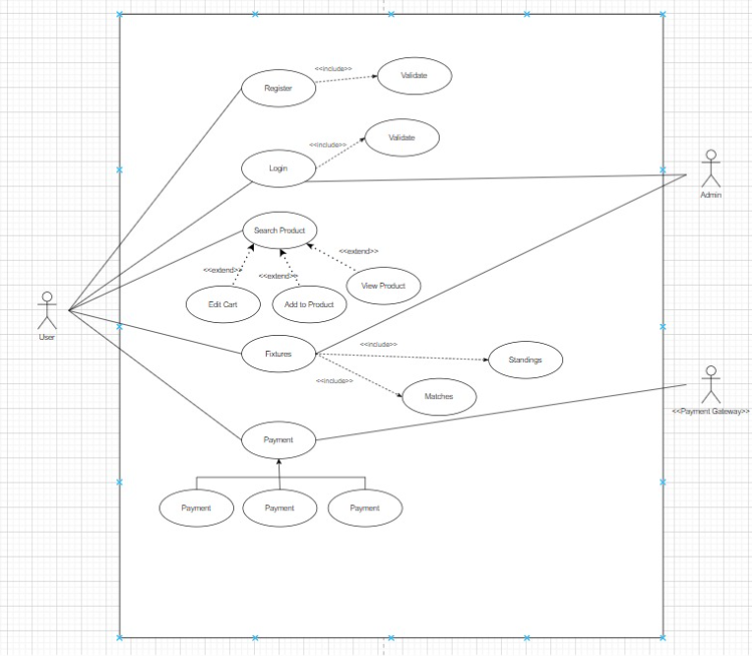

|  |  |
| --- | --- |
| Use Case Name | System |
| Actor | Admin and User |
| Pre Condition | Admin have username and password |
| Description | It Describes the whole system |
| Basic Flow | * User need to register first . * User need to login * User can access fixtures and e-commerce store. * User can purchase products * User have profile ,address , order , cart details page * Admin can manage users accordingly * Admin can view support. |
| Post Condition | System details get saved in database |

3.1.2 Registration & Login

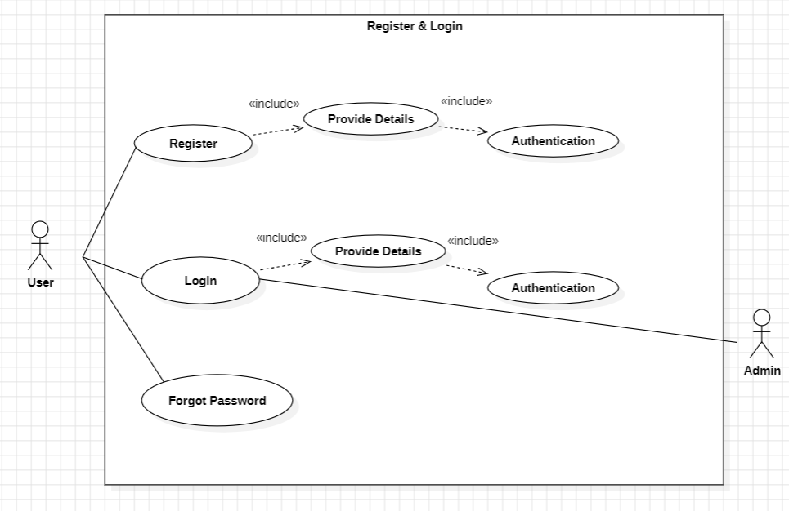

|  |  |
| --- | --- |
| Use Case Name | Registration and login |
| Actor | Admin and User |
| Pre Condition | Admin have own system and their login account |
| Description | Admin logins and access the system |
| Basic Flow | * User need to register first . * User need to login * User have profile ,address , order , cart details page |
| Post Condition | Admin and user have their own logins |

3.1.3 Fixtures

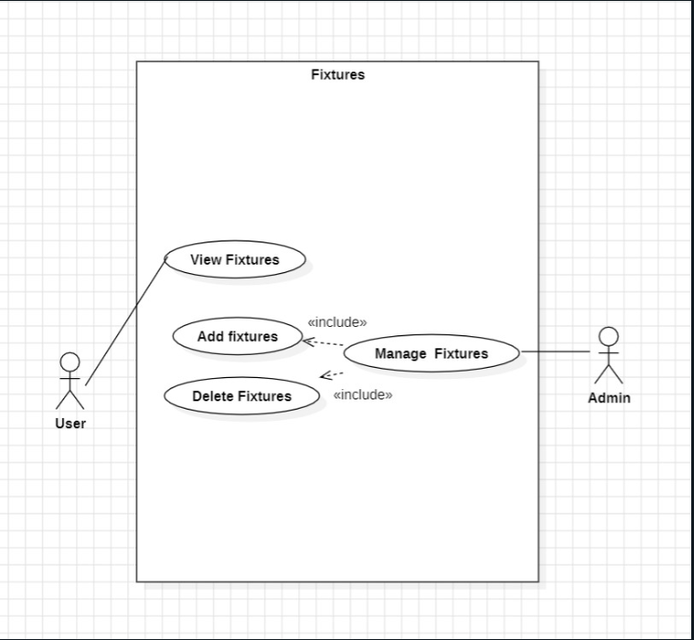

|  |  |
| --- | --- |
| Use Case Name | Fixtures |
| Actor | Admin and User |
| Pre Condition | users have their own login account |
| Description | Users can access fixtures |
| Basic Flow | * User need to login * User can view fixtures that includes players , standings and matchers. * Admin can manage fixtures |
| Post Condition | Fixtures are working properly. |

3.1.4 Order

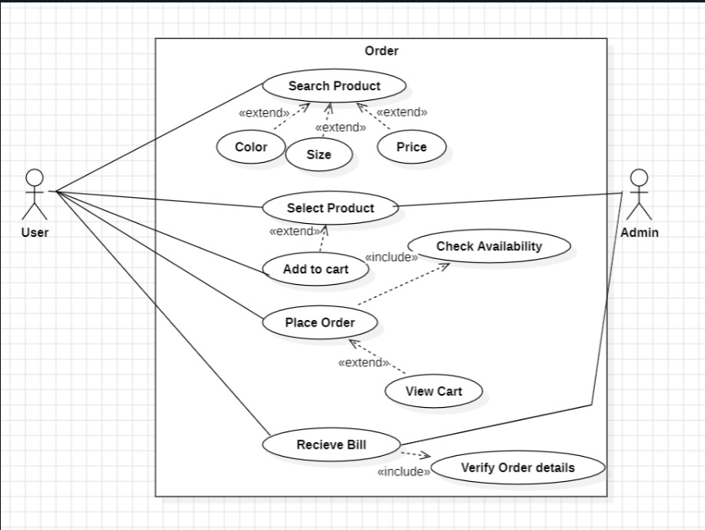

|  |  |
| --- | --- |
| Use Case Name | Order |
| Actor | Admin and User |
| Pre Condition | users have rights to order |
| Description | Users can access fixtures |
| Basic Flow | * User need to login * User can order products * Admin can manage Products * Users receives bill once order is placed |
| Post Condition | Orders placed successfully. |

3.1.5 Payment Gateway

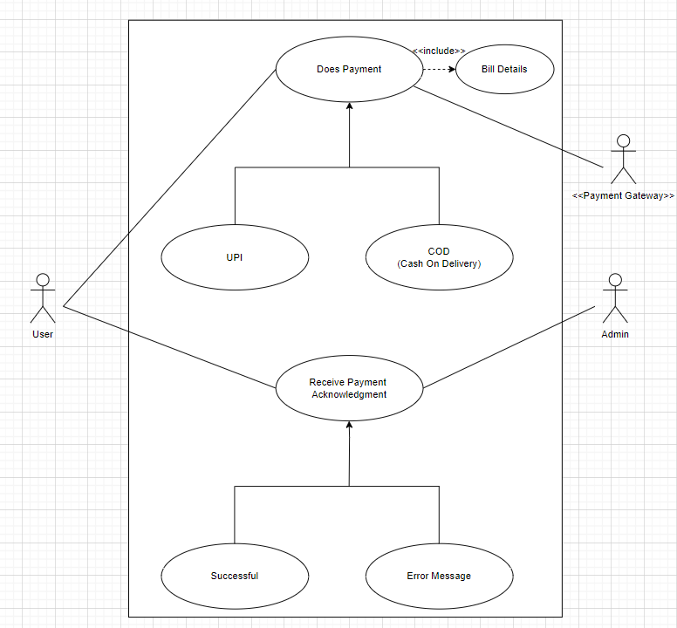

|  |  |
| --- | --- |
| Use Case Name | Payment |
| Actor | Admin and User |
| Pre Condition | users can pay once order is confiremed |
| Description | Users can order products |
| Basic Flow | * User need to login * User can order products * Users receives bill once order is placed * Admin receives payment details. |
| Post Condition | Payment done successfully. |

**3.2 Activity Diagram**

3.2.1 System

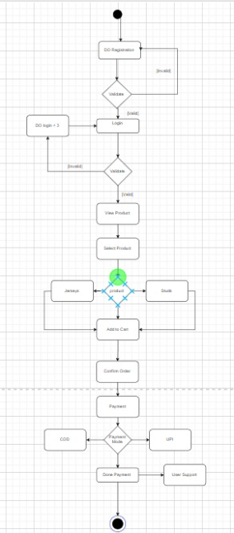

3.2.2 Register & Login

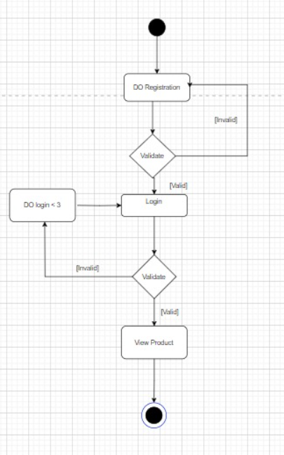

3.2.3 Fixtures

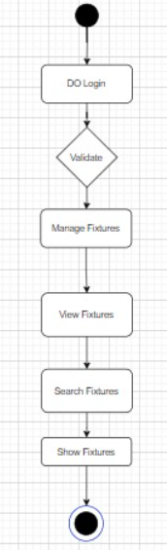

3.2.4 Order

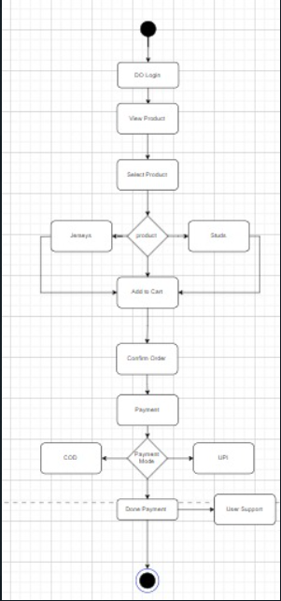

3.2.5 Payment Gateway

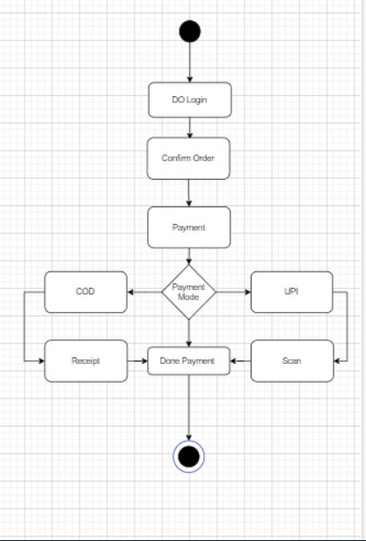

**3.3. Sequence Diagram**

3.3.1 System

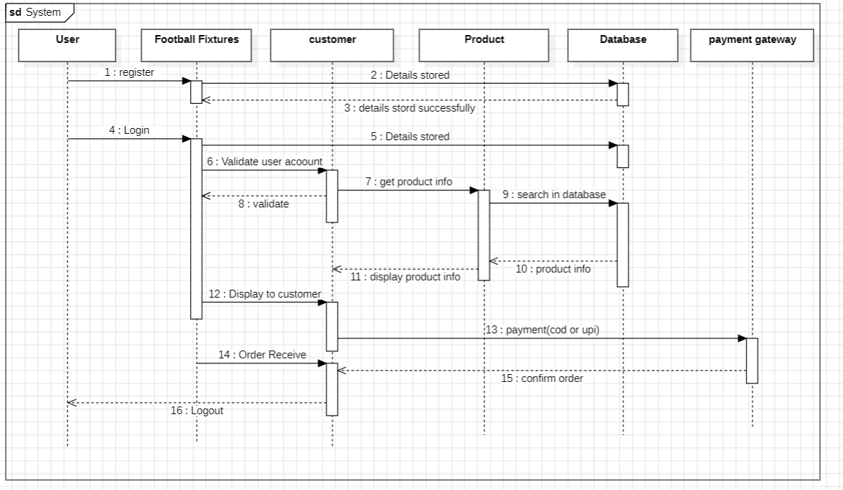

3.3.2 Register & Login

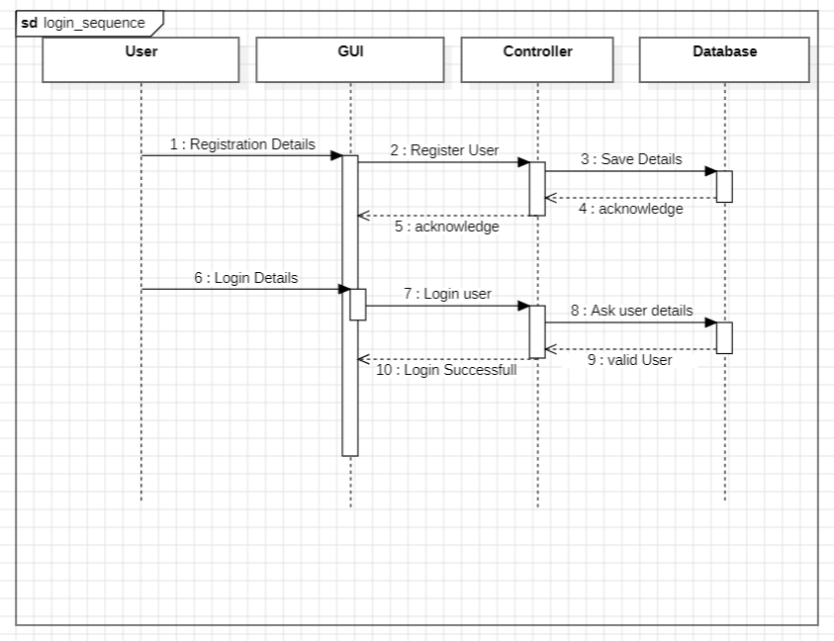

3.3.3 Order

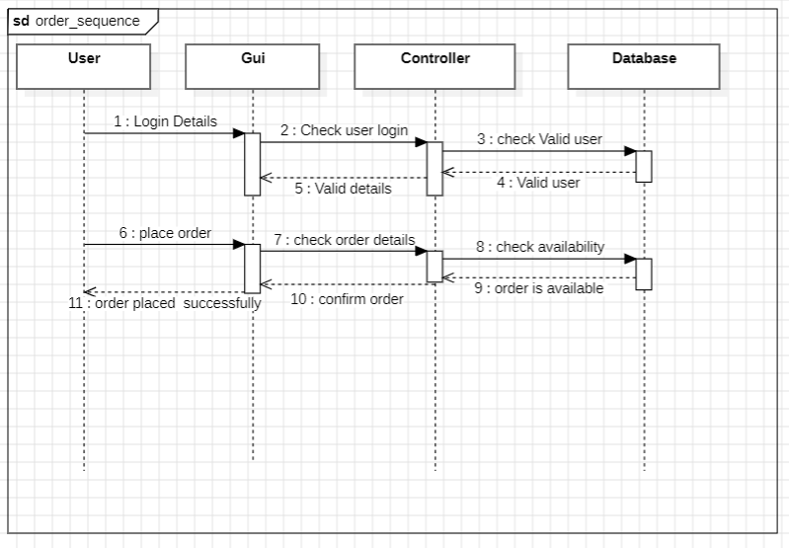

3.3.4 Payment gateway

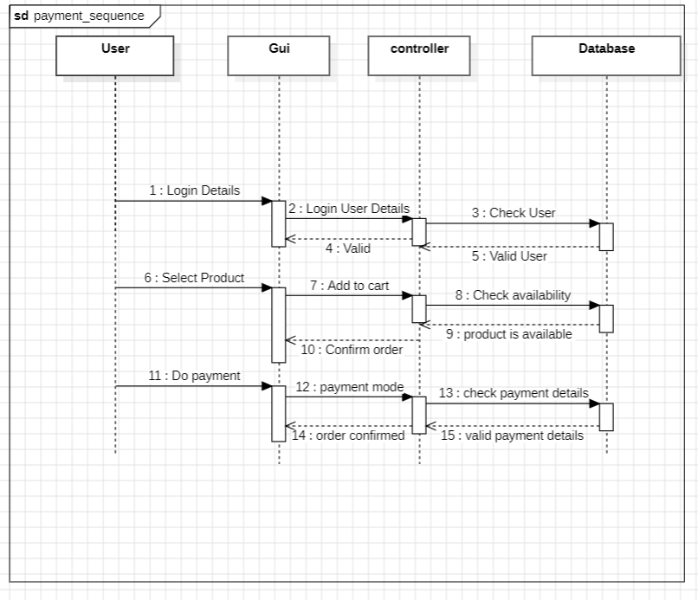

* 1. **Class Diagram**

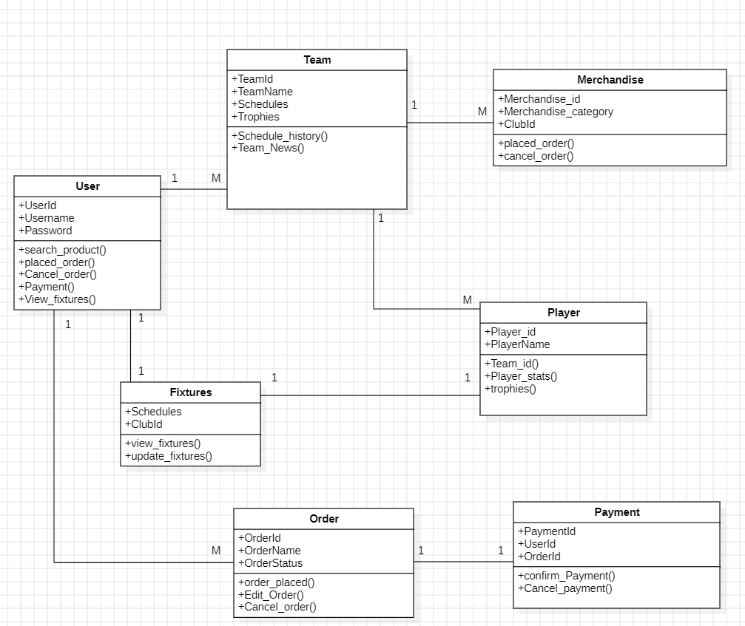

**3.5 ER Diagram**

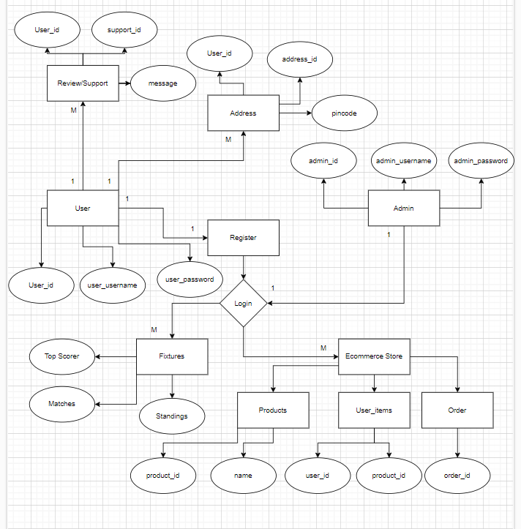

**3.6 Hierarchical Diagram**

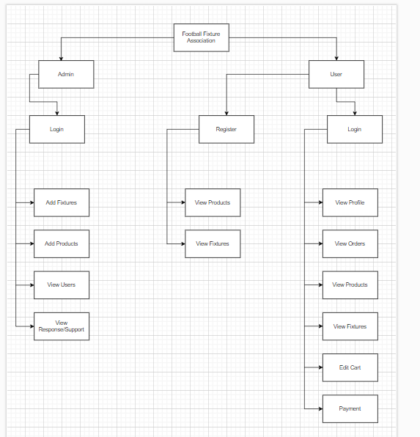

**3.7 Table specifications (Database design)**

**Admin**

|  |  |  |  |  |
| --- | --- | --- | --- | --- |
| **Field Name** | **Data Type** | **Size** | **Constraint** | **Description** |
| admin_id | int | 10 | PK | Admin id auto generated |
| admin_username | varchar | 100 | Not null | Admin username: adminffa |
| admin_password | varchar | 100 | Not null | Admin password: admin |

**User**

|  |  |  |  |  |
| --- | --- | --- | --- | --- |
| **Field Name** | **Data Type** | **Size** | **Constraint** | **Description** |
| user_id | int | 10 | PK | User id auto generated |
| name | varchar | 100 | Not null | User name |
| mobile | int | 10 | Not null | User mobile number 10 digit |
| email | varchar | 100 | Not null | User valid email id |
| password | varchar | 100 | Not null | User select valid password |

**Address**

|  |  |  |  |  |
| --- | --- | --- | --- | --- |
| **Field Name** | **Data Type** | **Size** | **Constraint** | **Description** |
| user_id | int | 100 | FK | User table user_id referred |
| address_id | int | 100 | PK | Address id auto generated |
| name | varchar | 100 | Not null | Name of Addresse |
| mobile | int | 10 | Not null | Mobile number of Addresse |
| pincode | int | 6 | Not null | Pincode of Addresse |
| locality | varchar | 100 | Not null | Area of Addresse |
| city | varchar | 100 | Not null | City of Addresse |
| state | varchar | 100 | Not null | State provide correct |
| landmark | varchar | 100 | Not null | Checkmark for proper mapping |
| alt_mobile | int | 10 | Not null | Alternate mobile number 10 digit |

**Product**

|  |  |  |  |  |
| --- | --- | --- | --- | --- |
| **Field Name** | **Data Type** | **Size** | **Constraint** | **Description** |
| user_id | int | 10 | FK | User table user_id referred |
| product_id | int | 10 | PK | Product_id auto generated |
| name | varchar | 100 | Not null | Product name |
| Brand | varchar | 100 | Not null | Product brand ex. Nike |
| price | int | 100 | Not null | Product Price |
| category | varchar | 100 | Not null | Product Category ex. clohing |
| image | varchar | 100 | Not null | Product Image to specify item |

**Reviews / Support**

|  |  |  |  |  |
| --- | --- | --- | --- | --- |
| **Field Name** | **Data Type** | **Size** | **Constraint** | **Description** |
| user_id | int | 10 | FK | User table uer_id referred |
| support_id | int | 10 | PK | Support_id auto generated |
| message | varchar | 100 | Not null | Message provided by the users for betterment |
| Subject | varchar | 100 | Not null | Message related to specific issue |
| time | varchar | 100 | Not null | Time field will include at what date and time it was sent through user |

**User Items**

|  |  |  |  |  |
| --- | --- | --- | --- | --- |
| **Field Name** | **Data Type** | **Size** | **Constraint** | **Description** |
| user_id | int | 10 | FK | User table user_id referred |
| user_items_id | int | 10 | PK | User_items_id auto generated |
| product_id | int | 10 | FK | Product table product_id referred |
| quantity | int | 10 | Not null | Quantity of product ex.1 or 2 |
| time | varchar | 100 | Not null | Time field will include at what date and time user purchased the product |
| status | varchar | 100 | Not null | Whether order is confirm or not |

**3.8 Data Dictionary**

|  |  |  |  |  |  |  |
| --- | --- | --- | --- | --- | --- | --- |
| **Sr.**  **No.** | **Field Name** | **Data Type** | **Size** | **Constraint** | **Description** | **Table Name** |
| 1 | admin_id | int | 10 | PK | Admin id auto generated | Admin |
| 2 | admin_username | varchar | 100 | Not null | Admin username: adminffa | Admin |
| 3 | admin_password | varchar | 100 | Not null | Admin password: admin | Admin |
| 4 | user_id | int | 10 | PK | User id auto generated | User |
| 5 | name | varchar | 100 | Not null | User name | User |
| 6 | mobile | int | 10 | Not null | User mobile number 10 digit | User |
| 7 | email | varchar | 100 | Not null | User valid email id | User |
| 8 | password | varchar | 100 | Not null | User select valid password | User |

|  |  |  |  |  |  |  |
| --- | --- | --- | --- | --- | --- | --- |
| **Sr.**  **No.** | **Field Name** | **Data Type** | **Size** | **Constraint** | **Description** | **Table Name** |
| 9 | address_id | int | 100 | PK | Address id auto generated | Address |
| 10 | name | varchar | 100 | Not null | Name of Addresse | Address |
| 11 | mobile | int | 10 | Not null | Mobile number of Addresse | Address |
| 12 | pincode | int | 6 | Not null | Pincode of Addresse | Address |
| 13 | locality | varchar | 100 | Not null | Area of Addresse | Address |
| 14 | city | varchar | 100 | Not null | City of Addresse | Address |
| 15 | state | varchar | 100 | Not null | State provide correct | Address |
| 16 | landmark | varchar | 100 | Not null | Checkmark for proper mapping | Address |
| 17 | alt_mobile | int | 10 | Not null | Alternate mobile number 10 digit | Address |

|  |  |  |  |  |  |  |
| --- | --- | --- | --- | --- | --- | --- |
| **Sr.**  **No.** | **Field Name** | **Data Type** | **Size** | **Constraint** | **Description** | **Table Name** |
| 18 | product_id | int | 10 | PK | Product_id auto generated | Product |
| 19 | name | varchar | 100 | Not null | Product name | Product |
| 20 | Brand | varchar | 100 | Not null | Product brand ex. Nike | Product |
| 21 | price | int | 100 | Not null | Product Price | Product |
| 22 | category | varchar | 100 | Not null | Product Category ex. clohing | Product |
| 23 | image | varchar | 100 | Not null | Product Image to specify item | Product |
| 24 | support_id | int | 10 | PK | Support_id auto generated | Support |
| 25 | message | varchar | 100 | Not null | Message provided by the users for betterment | Support |
| 26 | Subject | varchar | 100 | Not null | Message related to specific issue | Support |
| 27 | time | varchar | 100 | Not null | Time field will include at what date and time it was sent through user | Support |

|  |  |  |  |  |  |  |
| --- | --- | --- | --- | --- | --- | --- |
| **Sr.**  **No.** | **Field Name** | **Data Type** | **Size** | **Constraint** | **Description** | **Table Name** |
| 28 | user_items_id | int | 10 | PK | User_items_id auto generated | User_Items |
| 29 | product_id | int | 10 | FK | Product table product_id referred | User_Items |
| 30 | quantity | int | 10 | Not null | Quantity of product ex.1 or 2 | User_Items |
| 31 | time | varchar | 100 | Not null | Time field will include at what date and time user purchased the product | User_Items |
| 32 | status | varchar | 100 | Not null | Whether order is confirm or not | User_Items |

**CHAPTER 4: USER MANUAL**

**4.1 User Interface Screens (Input): -**

**Home Lander Pages**

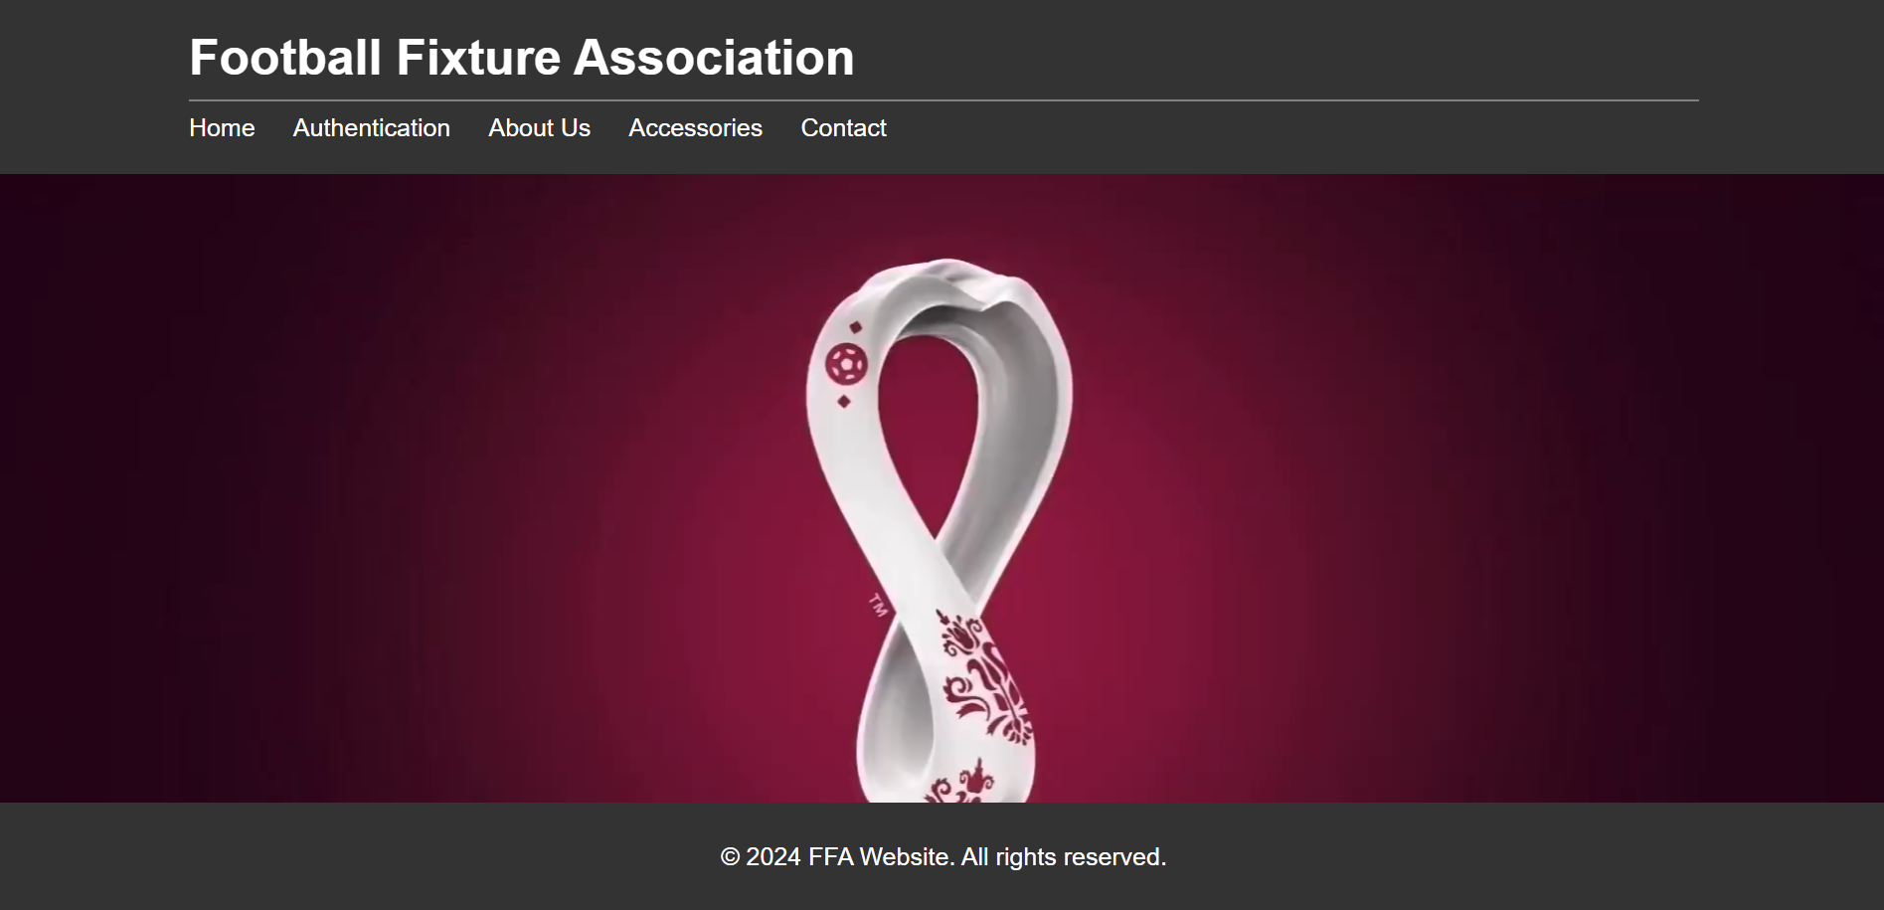

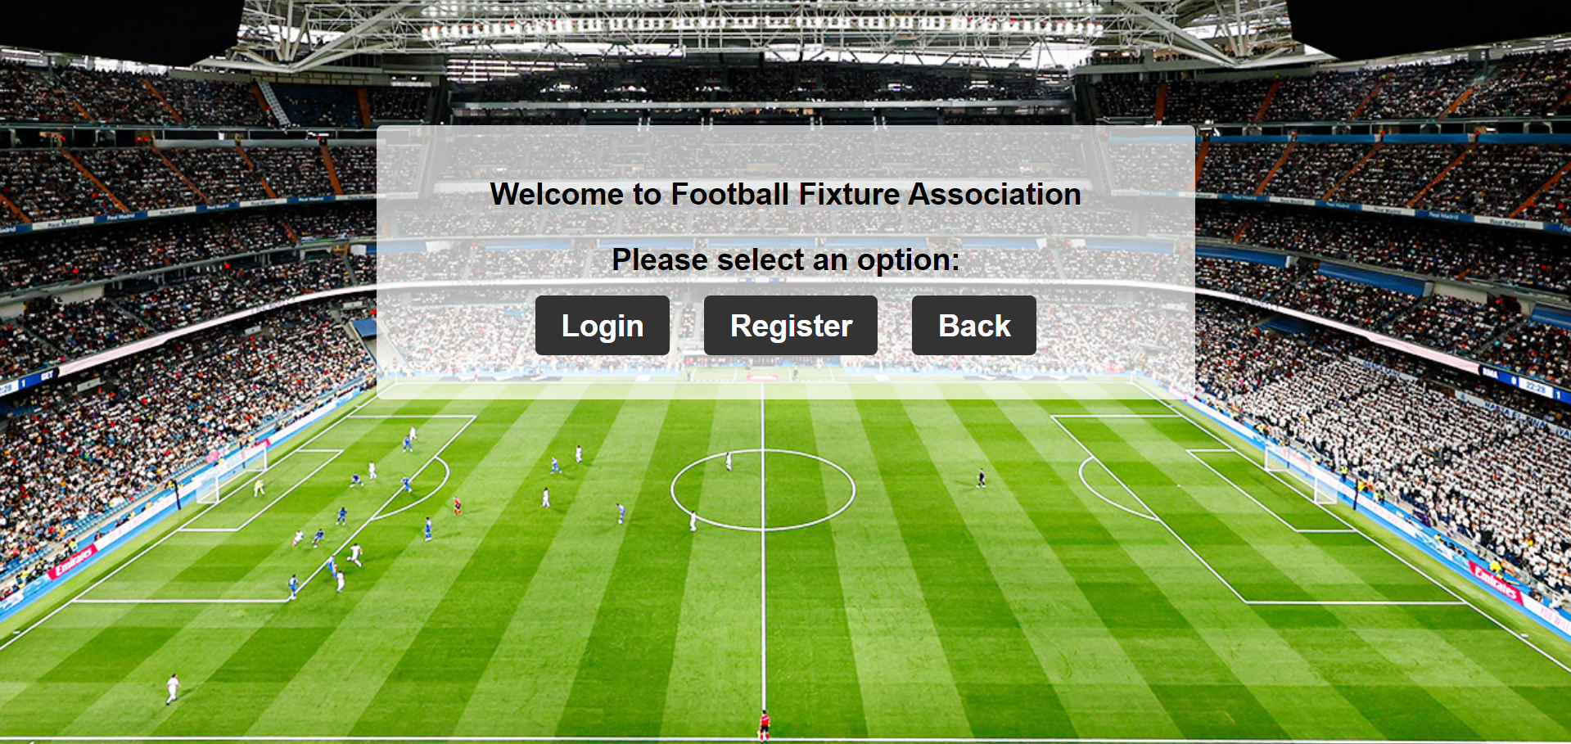

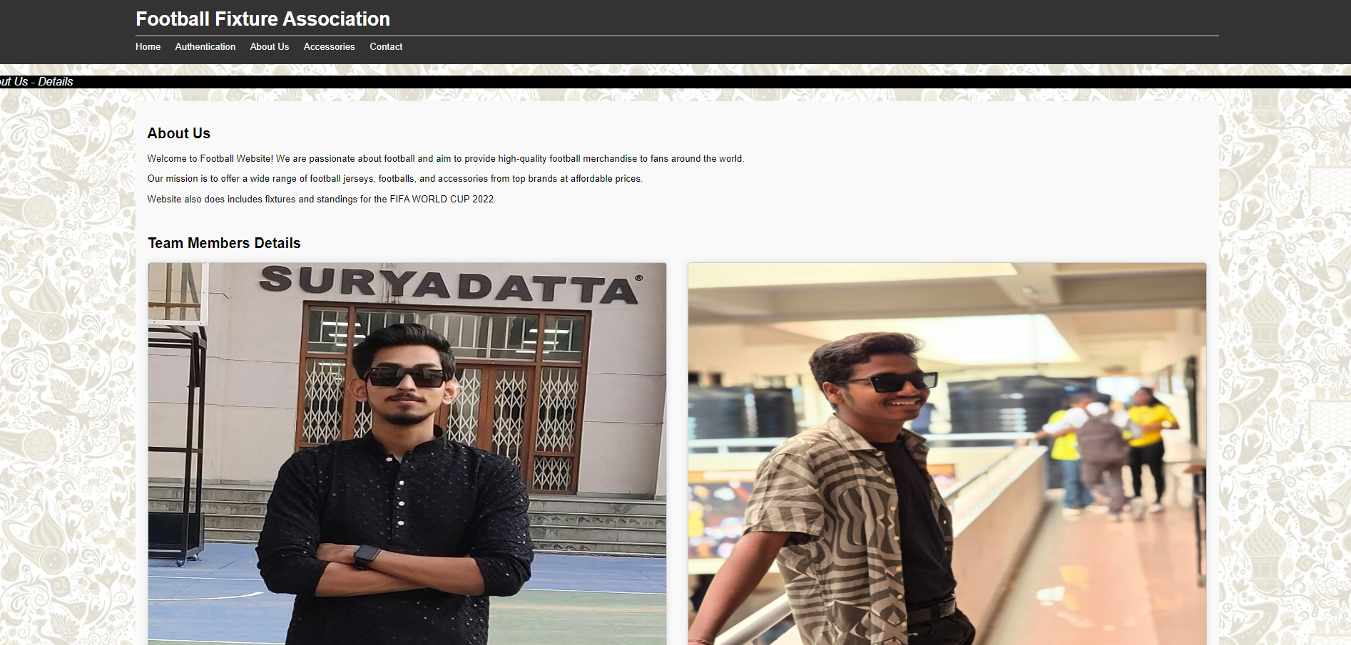

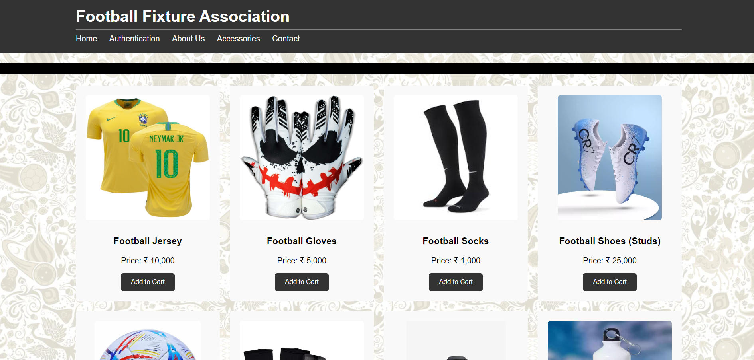

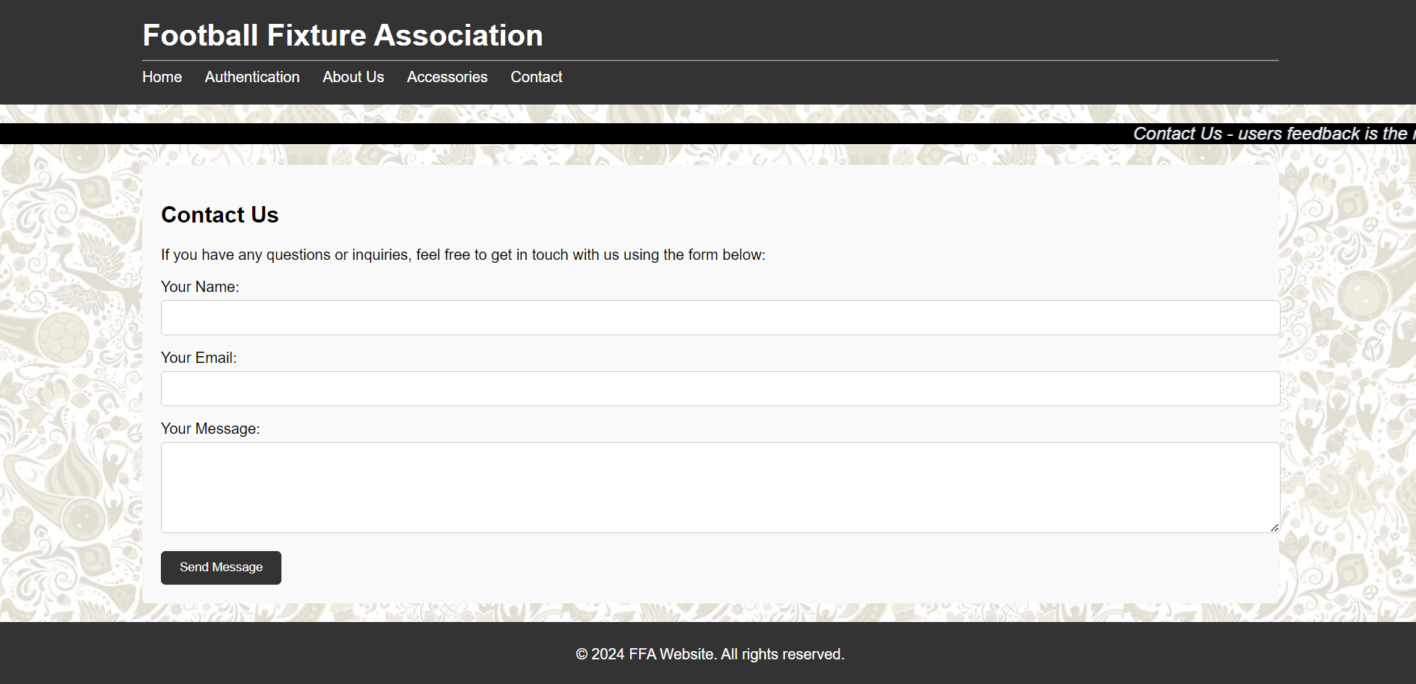

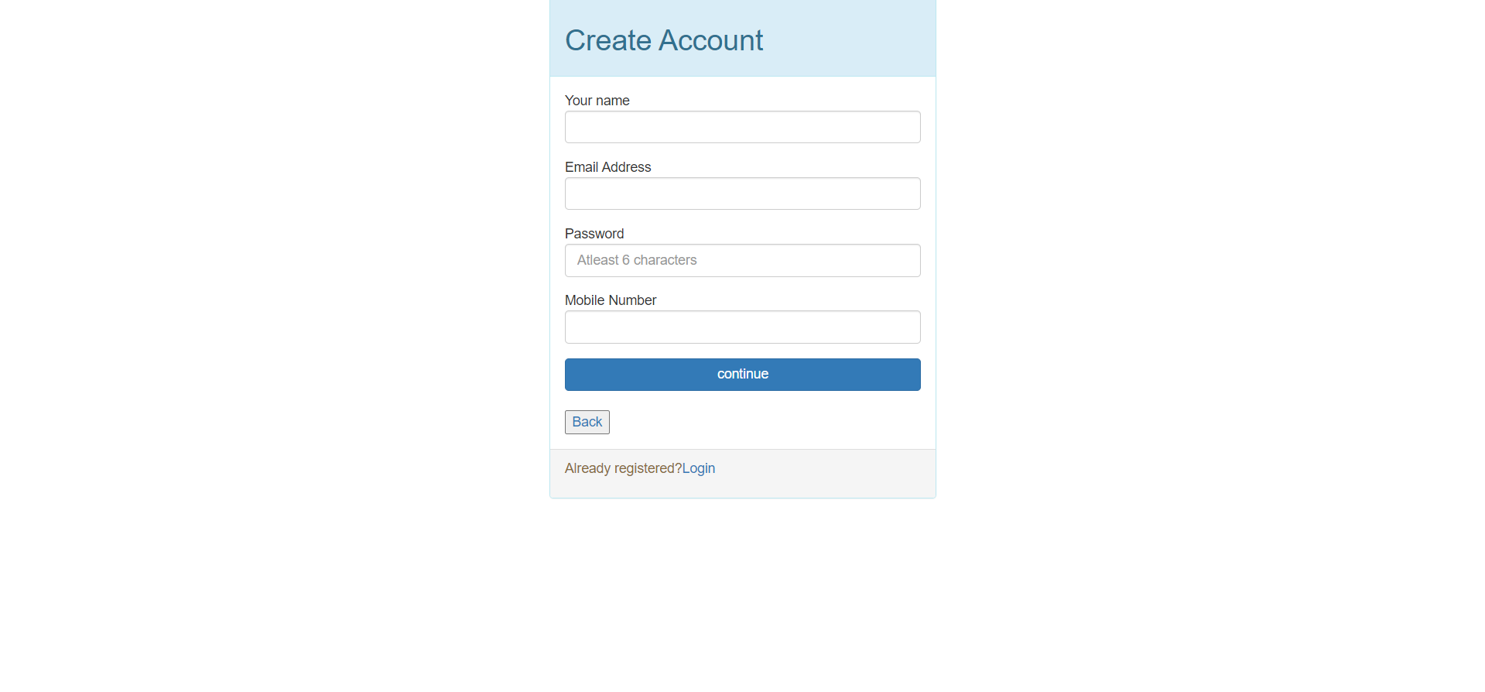

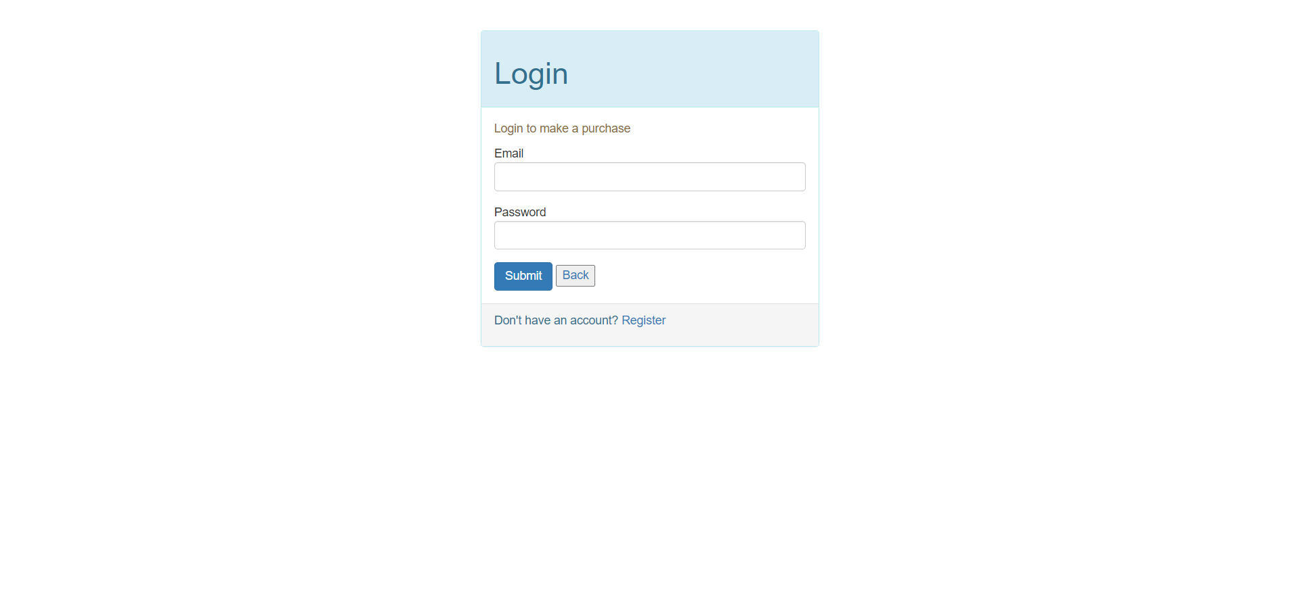

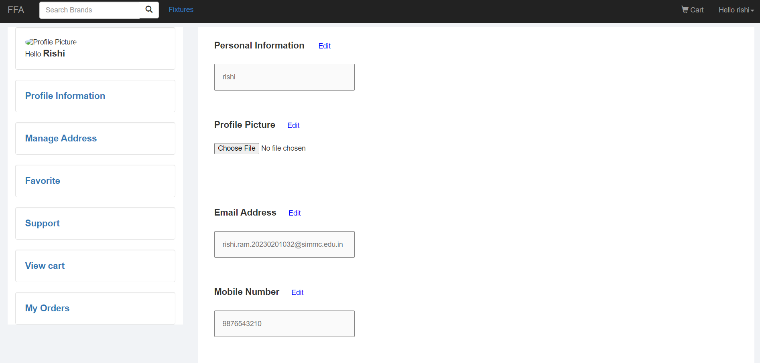

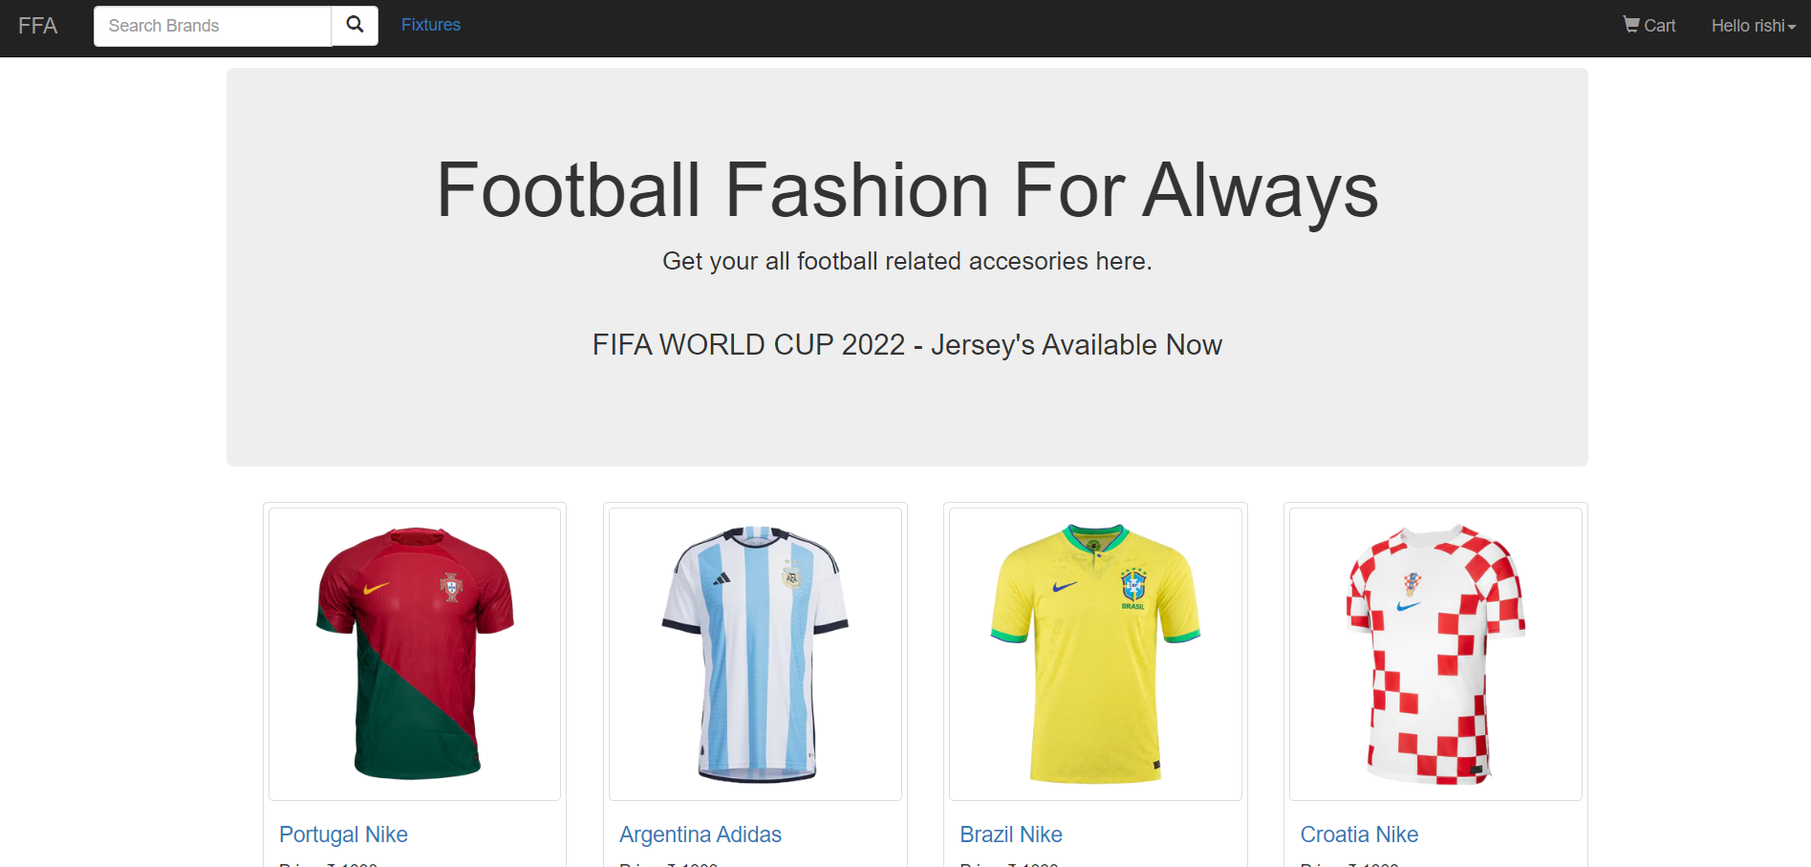

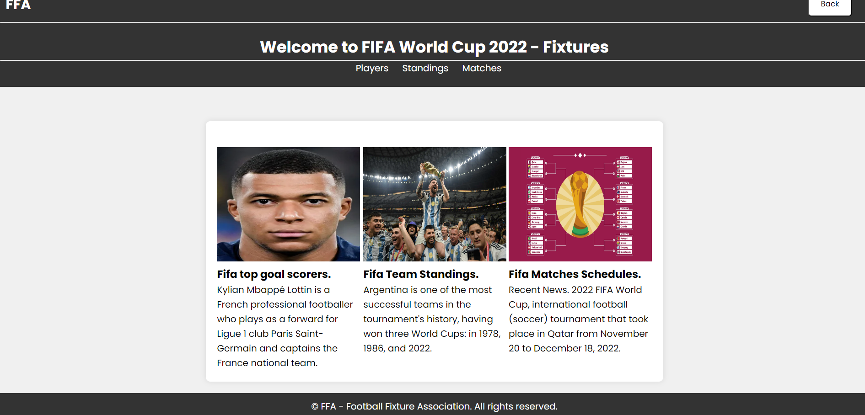

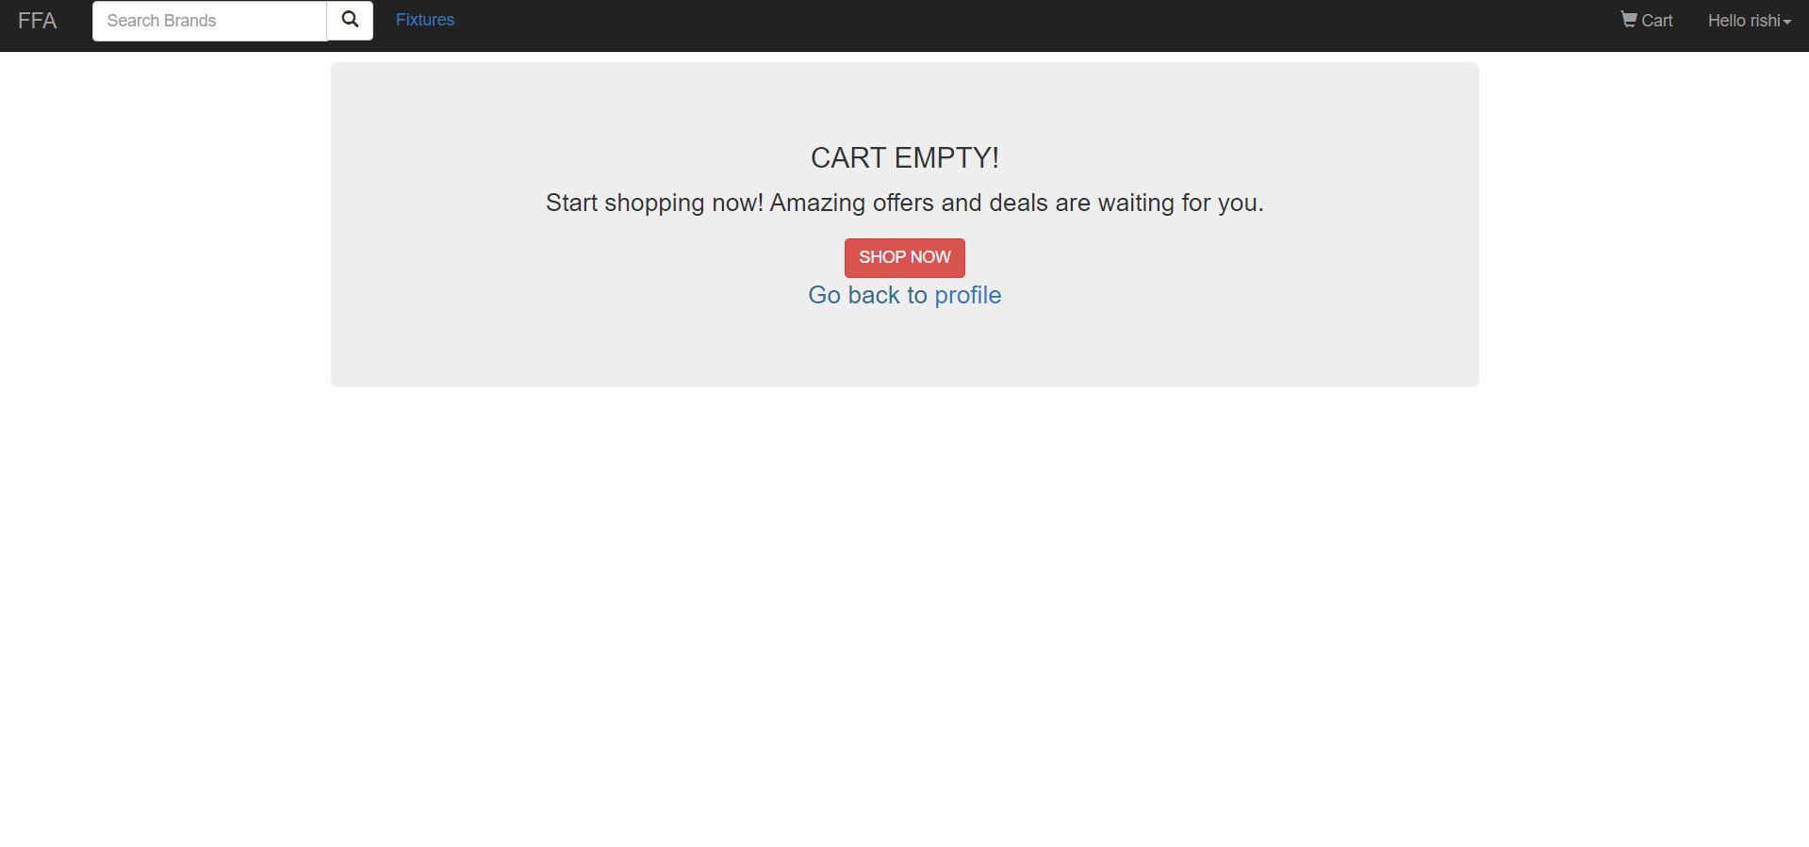

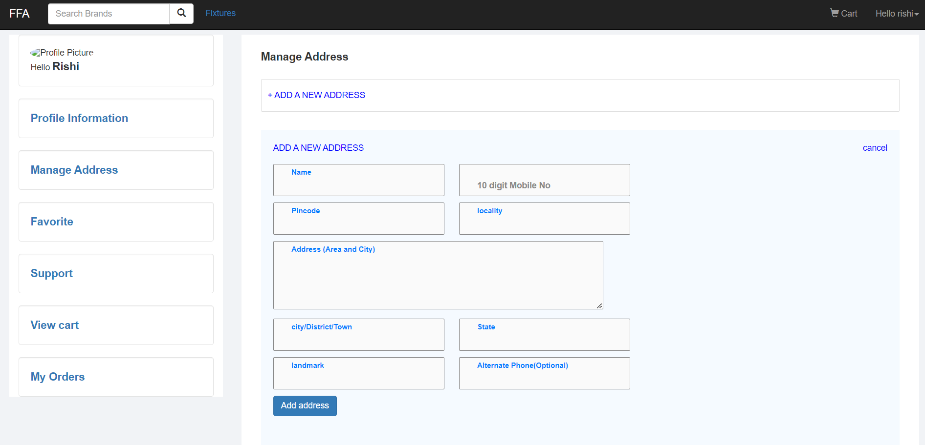

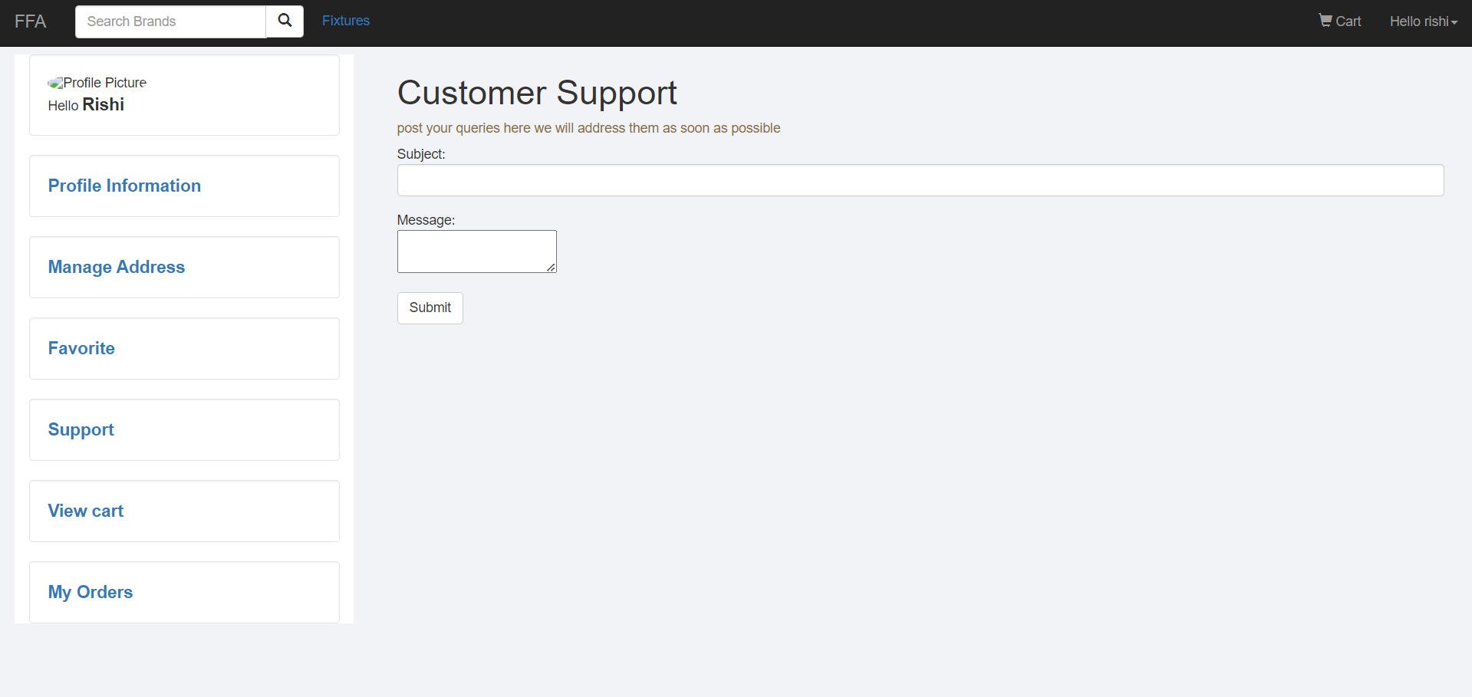

* 1. **User Interface Screens (Output): -**

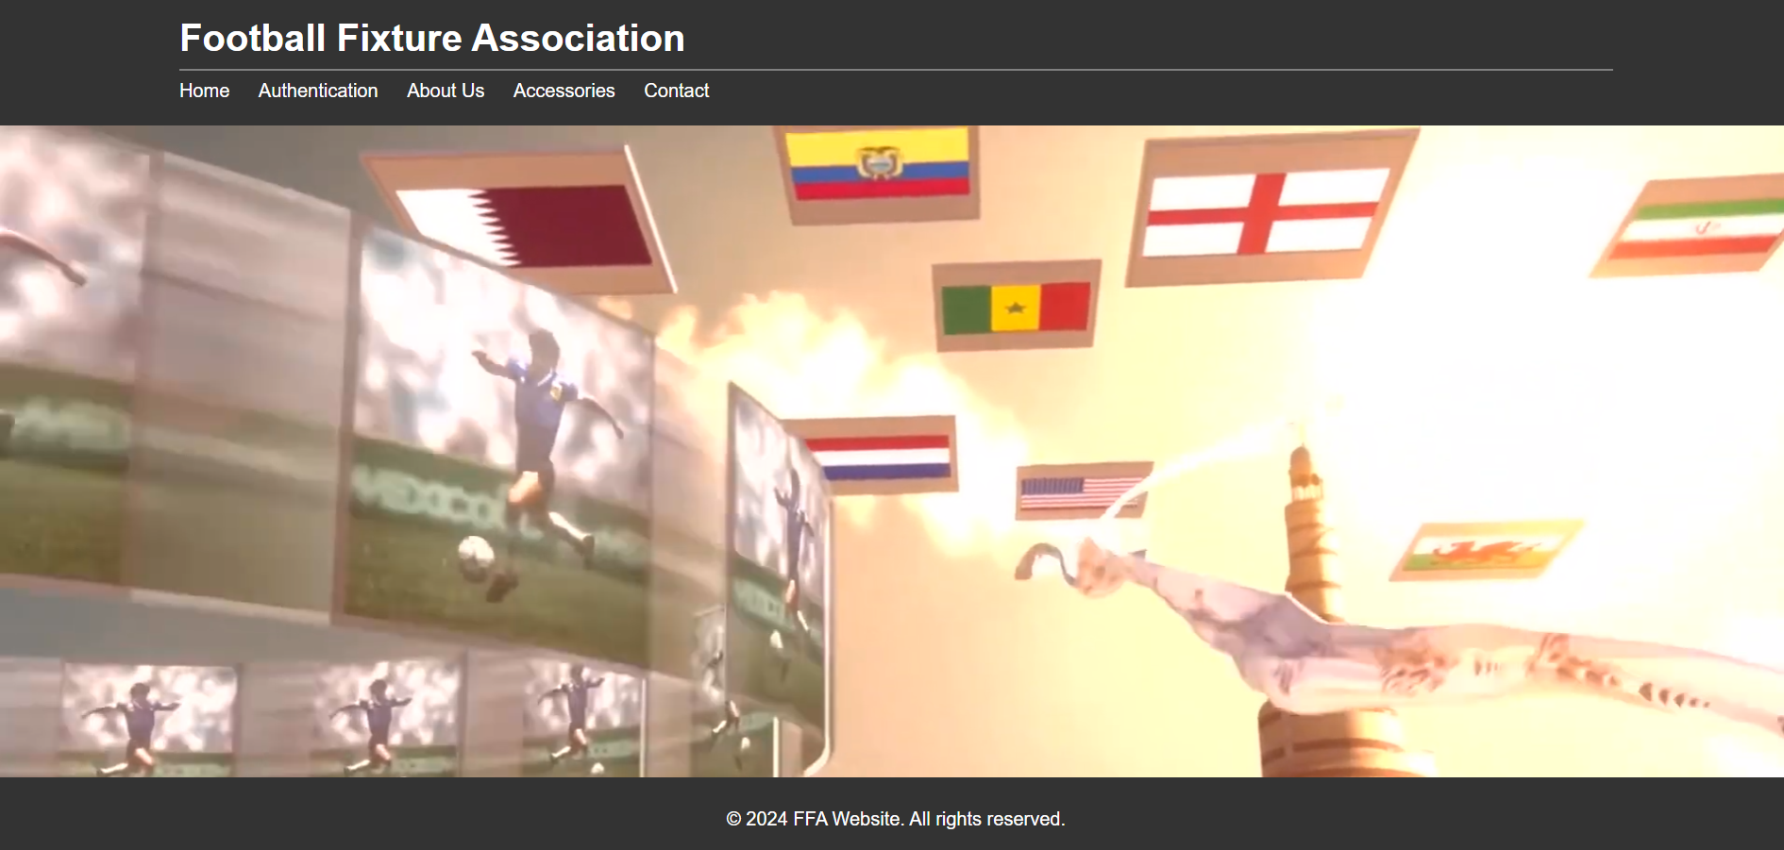

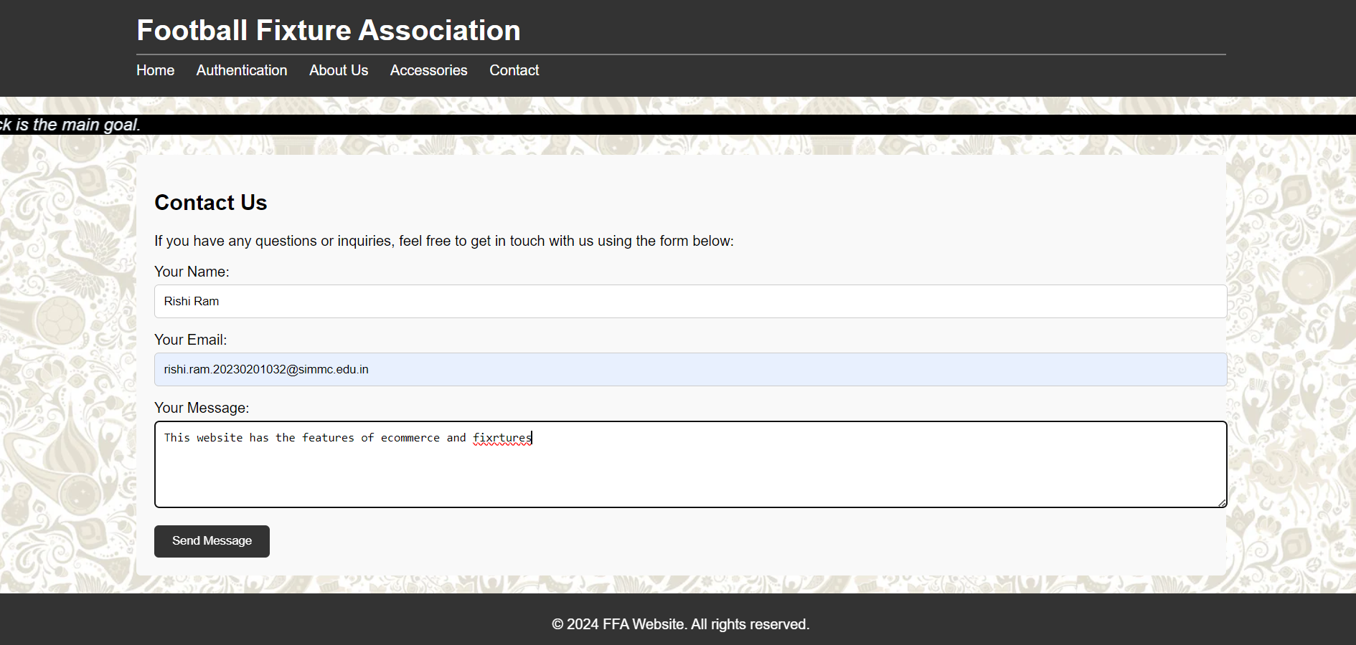

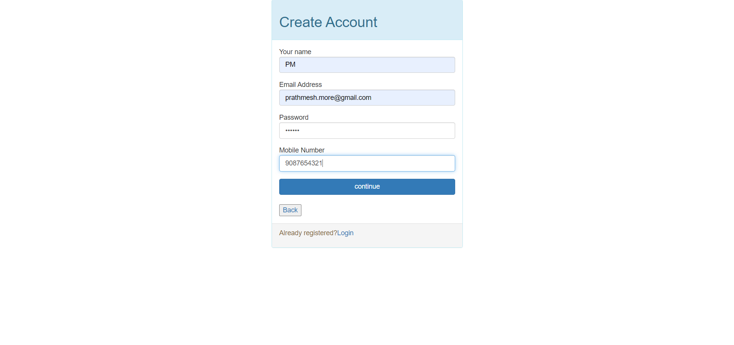

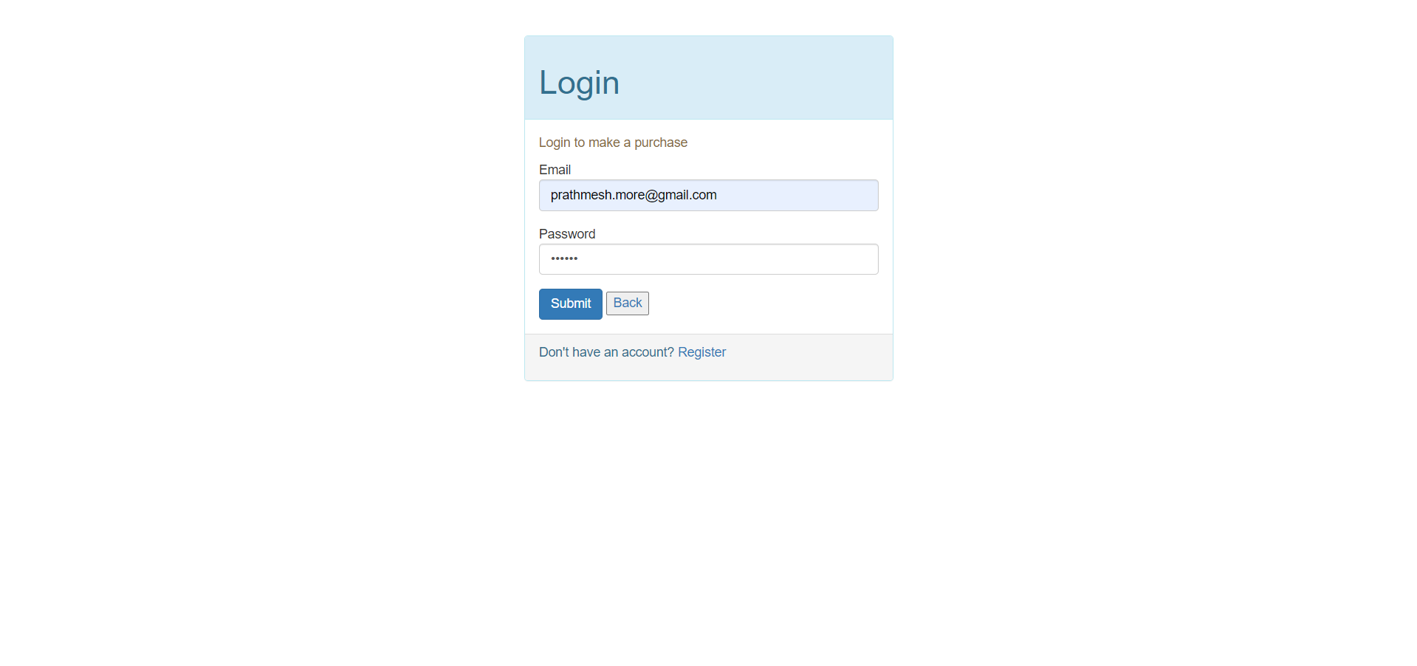

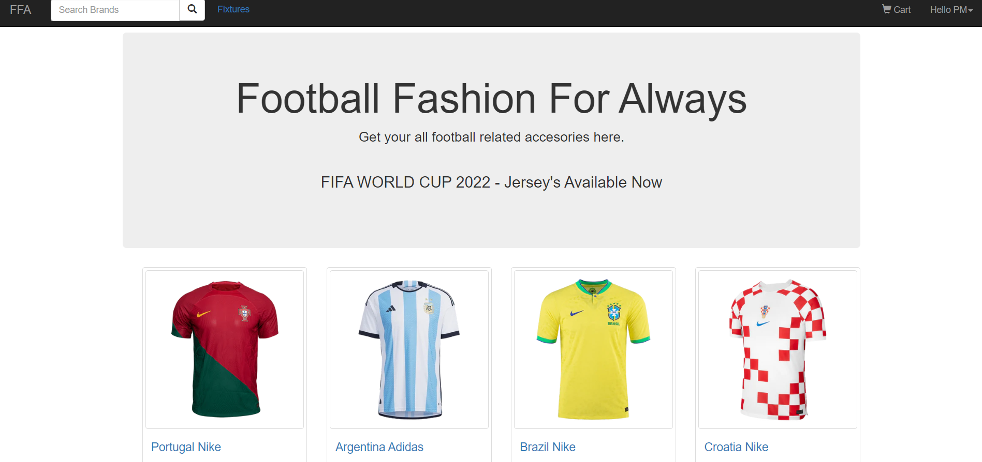

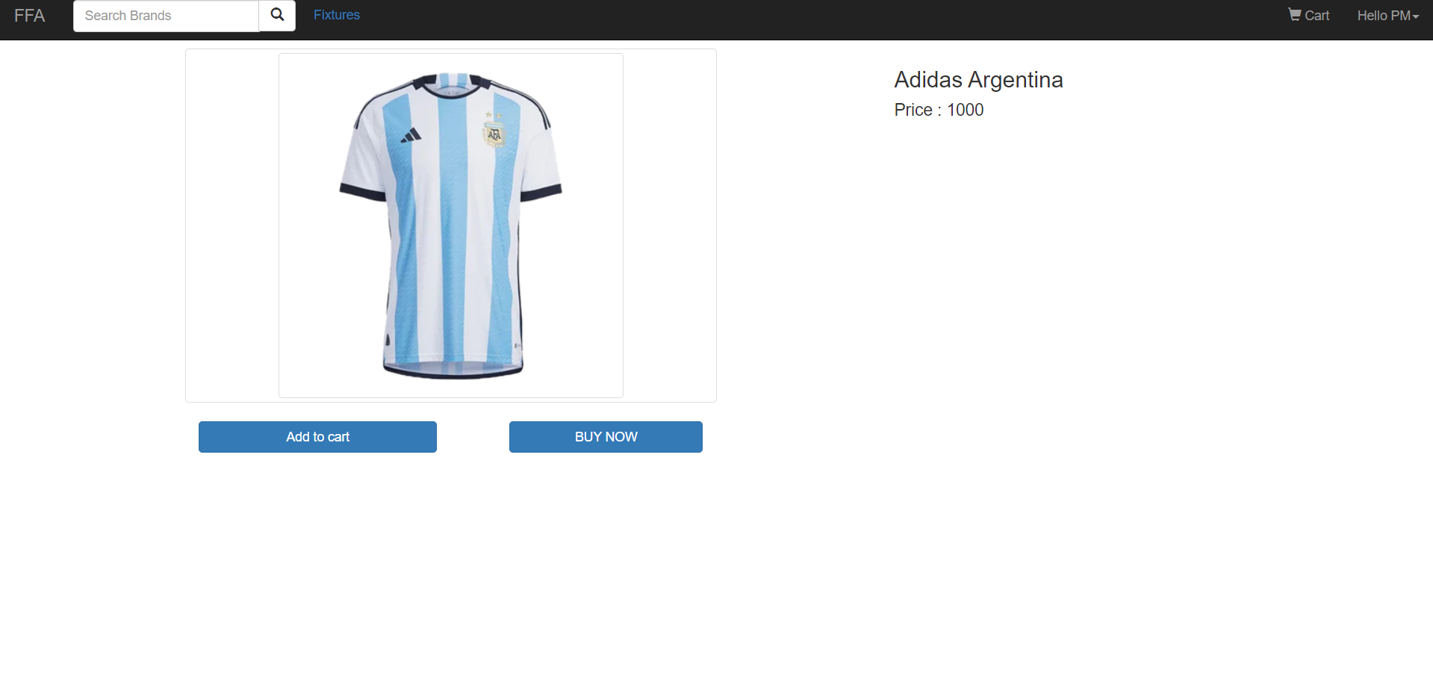

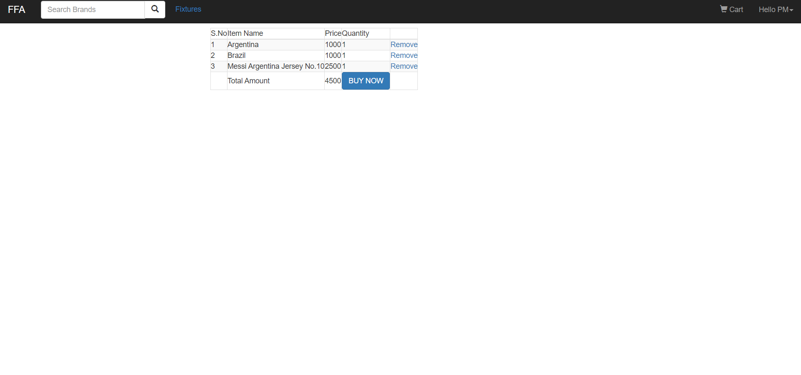

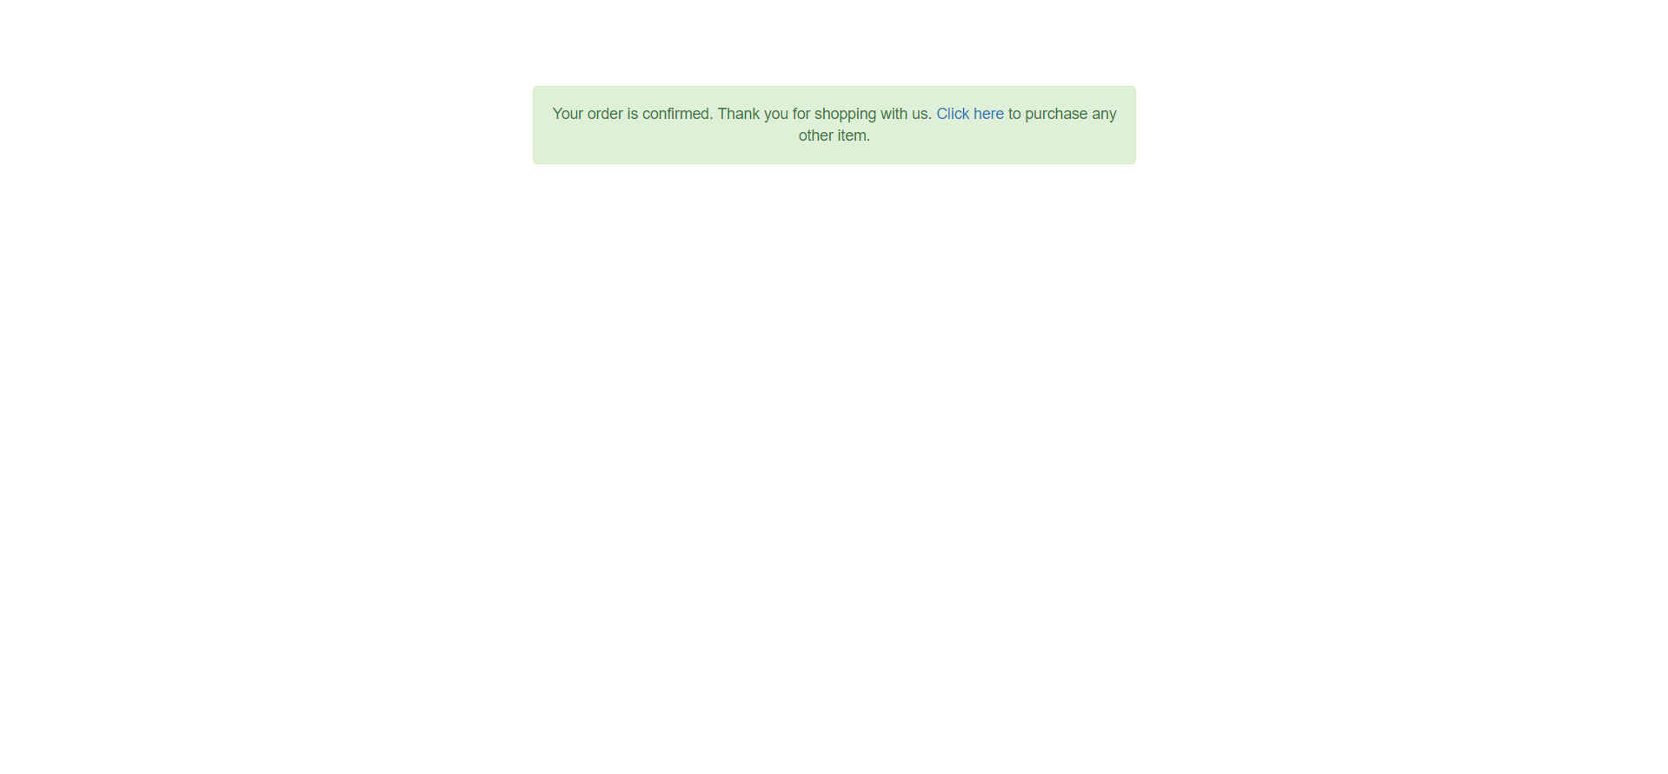

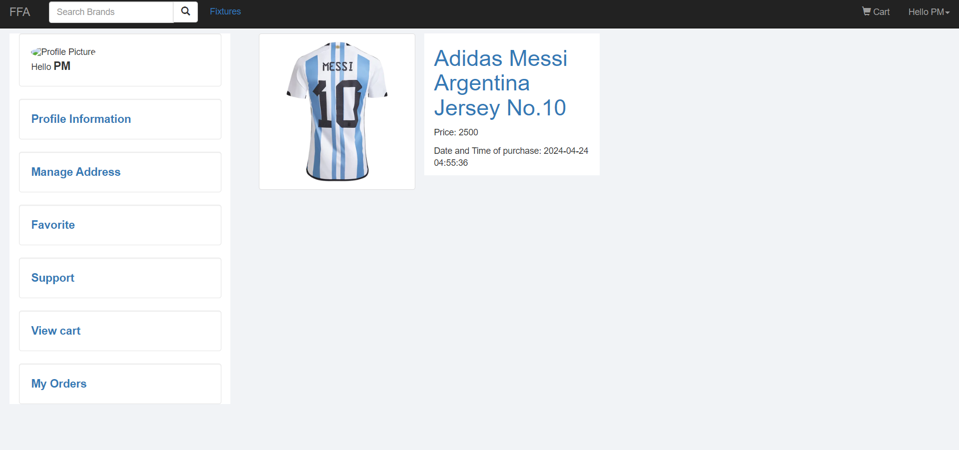

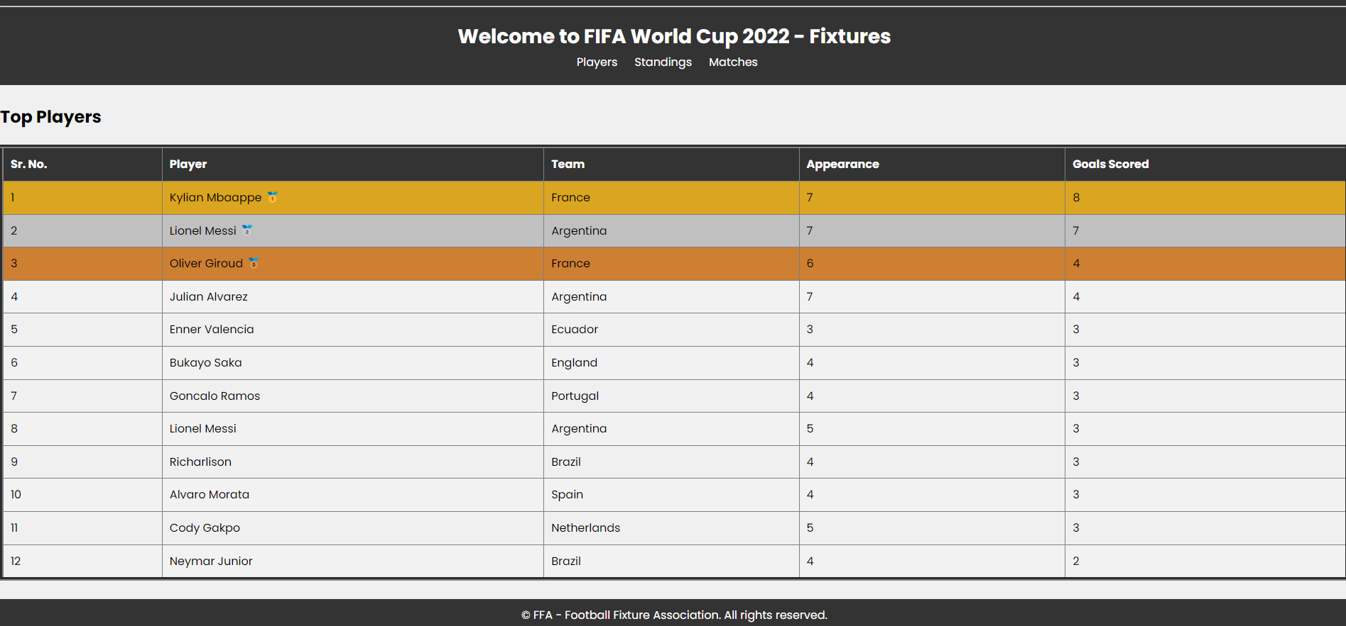

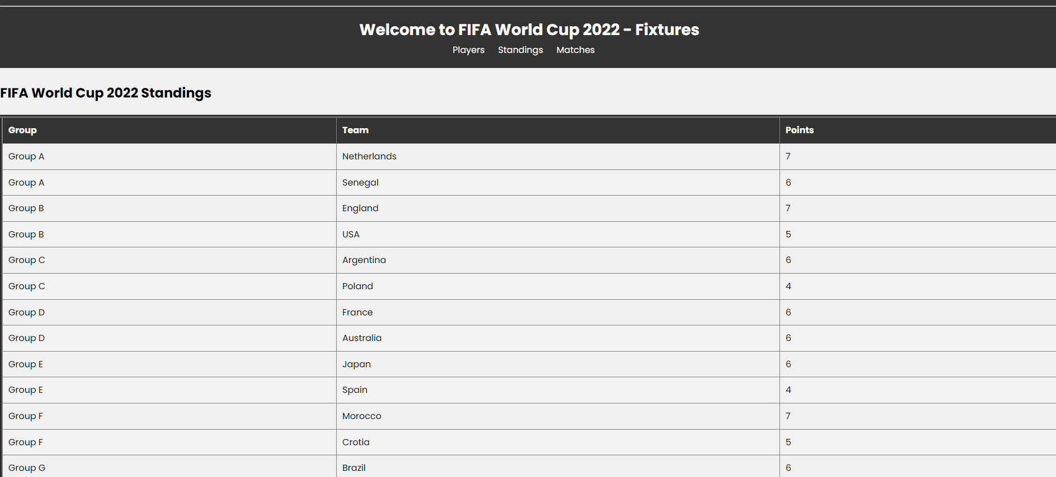

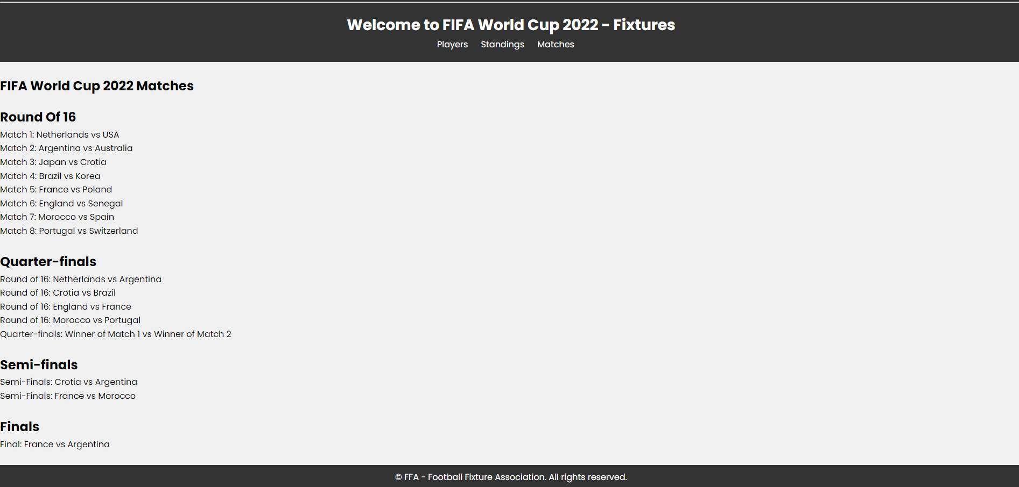

**4.3 Test Procedures and cases: -**

**Unit Testing: -**

* Unit testing is a level of software testing where individual units/ components of a software are tested. The purpose is to validate that each unit of the software performs as designed. A unit is the smallest testable part of any software. It usually has one or a few inputs and usually a single output. In procedural programming, a unit may be an individual program, function, procedure, etc.
* In object-oriented programming, the smallest unit is a method, which may belong to a base/ super class, abstract class or derived/ child class. (Some treat a module of an application as a unit. This is to be discouraged as there will probably be many individual units within that module.) Unit testing frameworks, drivers, stubs, and mock/ fake objects are used to assist in unit testing.

**Integration Testing: -**

* Integration testing is a level of software testing where individual units are combined and tested as a group. The purpose of this level of testing is to expose faults in the interaction between integrated units. Test drivers and test stubs are used to assist in Integration Testing.

**4.4 Sample program code: -**

**index.html**

<!DOCTYPE html>

<html lang="en">

<head>

<meta charset="UTF-8">

<meta name="viewport" content="width=device-width, initial-scale=1.0">

<title>FFA</title>

<link rel="stylesheet" href="indexhtml.css">

</head>

<body>

<header>

<div class="container">

<h1>Football Fixture Association</h1>

<hr noshade>

<nav>

<ul>

<li><a href="index.html">Home</a></li>

<li><a href="Auth.html">Authentication</a></li>

<li><a href="About.html">About Us</a></li>

<li><a href="Acce.html">Accessories</a></li>

<li><a href="Contact.html">Contact</a></li>

</ul>

</nav>

</div>

</header>

<main>

<video controls autoplay width="100%" height="100%">

<source src="indexvid.mp4" type="video/mp4">

</video>

</main>

<footer>

<div class="container">

<p>&copy; 2024 FFA Website. All rights reserved.</p>

</div>

</footer>

</body>

</html>

**indexhtml.css**

body {

font-family: Arial, sans-serif;

margin: 0;

padding: 0;

background-image:url(indexbg.jpg);

background-repeat: no-repeat;

background-size: cover;

}

header {

background-color: #333;

color: #fff;

padding: 20px 0;

}

.container {

width: 80%;

margin: 0 auto;

}

h1 {

margin: 0;

}

nav ul {

list-style: none;

padding: 0;

margin: 0;

}

nav ul li {

display: inline;

margin-right: 20px;

}

nav ul li a {

text-decoration: none;

color: #fff;

}

footer {

background-color: #333;

color: #fff;

text-align: center;

padding: 10px 0;

position: fixed;

bottom: 0;

width: 100%;

}

**index.php**

<!DOCTYPE html>

<html>

<head>

<?php

include 'include\common.php';

?>

<title>FFA</title>

<style>

/* Footer styles */

.footer {

background-color: #333;

color: #fff;

padding: 20px 0;

text-align: center;

}

.footer p {

margin: 0;

}

</style>

</head>

<body>

<?php include 'search_form.php';?>

<div class="container">

<div class="jumbotron" style="text-align: center;">

<!-- main page -->

<div class="main">

<div class="mainText">

<h1>Football Fashion For Always</h1>

<p>Get your all football related accesories here.</p>

</div>

</div>

<!-- shopping card -->

<div class="shop" id="shop">

<div class="head">

<hr noshade height="10%">

<h3>FIFA WORLD CUP <span>2022 - Jersey's Available Now</span></h3>

<hr noshade height="10%">

</div></div>

</div>

<div class='container'>

<?php

require_once 'include/Check-if-added.php';

$query=mysqli_query($con, "SELECT * FROM products ; ") ;

while ($row = mysqli_fetch_array($query)) { ?>

<div class="col-md-3 col-sm-6">

<div class="thumbnail">

<?php echo"<img src='admin/Image/".$row['image']."' class='img-thumbnail' >"; ?>

<div class="caption">

<?php echo "<a href='product_detail.php?id=".$row['id']."'><h4>".$row['name']." ".$row['brand']."</h4></a>"; ?>

<p>Price: ₹ <?php echo $row['price'] ; ?> </p>

</div>

</div>

</div>

<?php } ?>

</div>

<footer class="footer">

<div class="container">

<p>&copy; FFA - Football Fixture Association. All rights reserved.</p>

</div>

</footer>

</body>

</html>

**Fixtures.html**

<!DOCTYPE html>

<html lang="en">

<head>

<meta charset="UTF-8">

<meta name="viewport" content="width=device-width, initial-scale=1.0">

<title>Fixtures</title>

<link rel="stylesheet" href="Fixtures.css">

</head>

<body>

<div class="navbar">

<div class="logo">

<p><a style="color:white" href="Fixtures.html">FFA</a> </p>

</div>

<div class="nav-links">

<a href="index.php"> <button style="background-color: #ffffff;padding: 10px 20px;border-radius: 5px;">Back</button> </a>

</div>

</div>

<hr>

<header>

<h1>Welcome to FIFA World Cup 2022 - Fixtures</h1>

<hr>

<nav>

<ul>

<li><a href="Players.html">Players</a></li>

<li><a href="Standings.html">Standings</a></li>

<li><a href="Matches.html">Matches</a></li>

</ul>

</nav>

</header>

<main>

<div class="card">

&nbsp;

<img src="https://img.a.transfermarkt.technology/portrait/big/342229-1682683695.jpg?lm=1" height="200" width="250" >

<div class="card-description">

<h3>Fifa top goal scorers.</h3>

<p>Kylian Mbappé Lottin is a French professional footballer who plays as a forward for Ligue 1 club Paris Saint-Germain and captains the France national team. </p>

</div>

</div>

&nbsp;

<div class="card">

<img src="https://media.npr.org/assets/img/2022/12/19/gettyimages-1450300260_custom-c5af9bcf4c0a466c8d8bf155c5917cc4ee5b1d62-s1100-c50.jpg" height="200" width="250" >

<div class="card-description">

<h3>Fifa Team Standings.</h3>

<p>Argentina is one of the most successful teams in the tournament's history, having won three World Cups: in 1978, 1986, and 2022.</p>

</div>

</div>

&nbsp;

<div class="card">

<img src="https://miro.medium.com/v2/resize:fit:1200/1*-0T6gsOd4XaTegeyak0rdQ.png" height="200" width="250" >

<div class="card-description">

<h3>Fifa Matches Schedules.</h3>

<p>Recent News. 2022 FIFA World Cup, international football (soccer) tournament that took place in Qatar from November 20 to December 18, 2022.</p>

</div>

</div>

</main>

<footer>

<div class="container">

<p>&copy; FFA - Football Fixture Association. All rights reserved.</p>

</div>

</footer>

</body>

</html>

**cart.php**

<!DOCTYPE html>

<html>

<?php require 'search_form.php'; ;

if(!isset($_SESSION['email']))

header('location:login.php');

if(!empty($_GET['id'])){

$user_id = $_SESSION['user_id'];

$item_id = $_GET['id'];

$result = mysqli_query($con,"SELECT * FROM users_items WHERE user_id='".$_SESSION['user_id']."' AND product_id='".$item_id."';");

if(mysqli_num_rows($result)>0)

{

$row = mysqli_fetch_array($result);

$row['quantity']=$row['quantity']+1;

mysqli_query($con,"UPDATE users_items SET quantity ='".$row['quantity']."' WHERE user_id='$user_id' AND product_id='$item_id'") or die(mysqli_error($con));

}

else{

mysqli_query($con,"INSERT INTO users_items (user_id, product_id, quantity) VALUES('$user_id','$item_id','1') ;") or die(mysqli_error($con));}

}

?>

<head>

<title>FFA</title>

</head>

<body>

<?php

$i=1;

$sum=0;

$user_id = $_SESSION['user_id'];

$query=mysqli_query($con,"SELECT * FROM users_items, products WHERE users_items.product_id=products.id AND users_items.user_id='$user_id' AND status = 'added to cart'; ") or die(mysqli_error($con));

if(mysqli_num_rows($query)==0)

{?>

<div class="container-fluid">

<div class="col-sm-offset-2 col-sm-8 verticalCenter">

<div class="jumbotron ">

<center>

<h3>CART EMPTY!</h3>

<p>Start shopping now! Amazing offers and deals are waiting for you.</p>

<a href="index.php"><button class="btn btn-danger">SHOP NOW</button></a>

<p class="text-info">Go back to <a href="profile.php">profile</a></p>

</center>

</div>

</div>

</div>

<?php }

else{ ?>

<div class="container">

<div class="col-md-8 col-md-offset-2">

<table class="table-bordered table-responsive table-striped">

<thead>

<tr>

<td> S.No </td>

<td> Item Name </td>

<td> Price </td>

<td> Quantity </td>

<td> </td>

</tr>

</thead>

<tbody>

<?php while($row=mysqli_fetch_array($query)){ ?>

<tr>

<td><?php echo $i ?></td>

<td><?php echo $row['name']; ?></td>

<td><?php echo $row['price']; ?></td>

<td><?php echo $row['quantity']; ?></td>

<?php echo "<td><a href='cart-remove.php?id=".$row['product_id']."' class='remove-item-link'>Remove</a></td>" ; ?>

</tr>

<?php

$sum=$sum+$row['price']*$row['quantity'];

$i=$i+1;

$id=$row['id'].",";

$id = rtrim($id,",");

}

$_SESSION['item_id']=$id;

echo"<tr>

<td></td>

<td>Total Amount</td>

<td> $sum </td>

<td><form action='PaytmKit/pgRedirect.php' method='post'>

<!-- Please Enter ORDER_ID must required value -->

<input id='ORDER_ID' type='hidden' tabindex='1' name='ORDER_ID' value='ORDS" . rand(10000,99999999)."'>

<!-- CUST_ID Enter must-->

<input id='CUST_ID' type='hidden' tabindex='2' name='CUST_ID' value='CUST001'>

<!-- simple INDUSTRY_TYPE_ID enter with autocomplete-->

<input id='INDUSTRY_TYPE_ID' type='hidden' tabindex='4' name='INDUSTRY_TYPE_ID' value='Retail'>

<!-- Enter your channel Id here-->

<input id='CHANNEL_ID' type='hidden' tabindex='4' name='CHANNEL_ID' value='WEB'>

<!-- simple TXN_AMOUNT value Enter -->

<input title='TXN_AMOUNT' type='hidden' tabindex='10' name='TXN_AMOUNT' value='".$sum."'>

<input value='BUY NOW' type='submit' class='btn btn-primary'>

</form> </td>

</tr> ";

if(isset($_GET['error']))

echo htmlspecialchars($_GET['error']); ?>

</tbody>

<?php

//$_COOKIE["id"]=$id;

//echo "cookie with value ".$_COOKIE["id"];

?>

</table>

</div>

</div>

<?php

}

?>

</body>

</html>

**cart_remove.php**

<?php

require 'include/common.php' ;

if (isset($_GET['id']) && is_numeric($_GET['id'])) {

$item_id = $_GET['id'];

$user_id = $_SESSION['user_id'];

$item = mysqli_query($con,"SELECT * FROM users_items WHERE product_id='$item_id' AND user_id='$user_id'");

$row = mysqli_fetch_array($item);

// Delete the rows from user_items table where item_id and user_id equal to the item_id and user_id we got from the cart page and session

if( $row['quantity']>1){

$row['quantity']=$row['quantity']-1;

mysqli_query($con,"UPDATE users_items SET quantity ='".$row['quantity']."' WHERE user_id='$user_id' AND product_id='$item_id'") or die(mysqli_error($con));

}

else{

$query = "DELETE FROM users_items WHERE product_id='$item_id' AND user_id='$user_id' ";

$res = mysqli_query($con, $query) or die(mysqli_error($con));}

header("location:cart.php");

}

else {

if(!is_numeric($_GET['id'])){

header("location:cart.php?error=not numeric");

}

else

header("location:cart.php?error=not set");

}

?>

**admin.php**

<!DOCTYPE html>

<html>

<head>

<title>Admin</title>

<!-- INCLUDE STYLE SHEETS AND JAVASCRIPT -->

<link rel="stylesheet" href="https://maxcdn.bootstrapcdn.com/bootstrap/3.3.7/css/bootstrap.min.css">

<script src="https://ajax.googleapis.com/ajax/libs/jquery/3.3.1/jquery.min.js"></script>

<script src="https://maxcdn.bootstrapcdn.com/bootstrap/3.3.7/js/bootstrap.min.js"></script>

<!-- PASSWORD AND USERNAME FOR ADMIN PANEL-->

<?php $pwd = 'admin123';

$username = 'admin';

session_start();

?>

</head>

<body>

<br/>

<br/>

<!-- HTML FORM USING BOOTSTRAP-->

<div class='container-fluid'>

<div class='col-sm-offset-4 col-sm-4'>

<div class="panel panel-success">

<div class="panel-heading"><h1>Admin Login</h1></div>

<div class="panel-body">

<form action="" method="post">

<div class="form-group">

<label for='username'>Username</label>

<input type="text" name="username" class="form-control">

</div>

<div class="form-group">

<label for='password'>Password</label>

<input type="password" name="password" class="form-control">

</div>

<div class="text-danger"><?php if(isset($_GET['error'])){echo htmlspecialchars($_GET['error']);} ?></div>

<input type ='submit' class='btn btn-primary' value='submit' name='submit'>

</form>

</div>

</div>

</div>

</div>

<!--CHECKING IF PASSWORD AND USERNAME ENTERED BY USER MATCHES-->

<?php

if(isset($_POST['submit']))

{

if($_POST['username']===$username && $_POST['password']===$pwd)

{

header('location:Image/database.php');

$_SESSION['id']=$username;

}

else

{

header('location:http://localhost/search/admin/admin.php?error=Incorrect login credentials');

}

}

?>

</body>

</html>

**4.5 Limitations: -**

Limitations of FFA:

1. Data Accuracy: One limitation of the system could be the accuracy of the fixture information and merchandise availability. While efforts will be made to source data from reliable sources, there may still be instances of inaccuracies or discrepancies in the information provided.
2. Dependency on External Sources: The system may be dependent on external sources for fixture data, merchandise availability, and ticket bookings. Any disruptions or changes in these external sources could impact the functionality and reliability of the system.
3. Geographical Limitations: The availability of merchandise and ticket bookings may be limited to certain geographical regions or countries. Users outside of these regions may have limited access to certain products or services offered by the platform.
4. Technical Constraints: The system may face technical constraints such as server downtime, bandwidth limitations, and performance issues during peak usage periods. These constraints could impact the accessibility and responsiveness of the platform for users.
5. Security Risks: Despite efforts to ensure security, the system may be vulnerable to security risks such as data breaches, hacking attempts, and unauthorized access. These risks could compromise the confidentiality and integrity of user data and transactions within the platform.
6. User Engagement: While the system aims to enhance fan engagement, there may be limitations in the level of user participation and interaction within the platform. Factors such as user preferences, interests, and time constraints could impact the overall engagement and activity within the platform.
7. Regulatory Compliance: The system may need to comply with various regulatory requirements and industry standards, such as data protection laws and consumer rights regulations. Failure to comply with these requirements could result in legal implications and penalties for the platform.
8. Scalability Challenges: As the user base and data volume grow, the system may face scalability challenges in terms of infrastructure, storage, and processing capabilities. Efforts will be needed to ensure that the system can scale effectively to meet the growing demands of users.
9. Maintenance and Updates: Regular maintenance and updates will be required to keep the system up-to-date with the latest fixture information, merchandise offerings, and technological advancements. Failure to perform timely maintenance and updates could result in system vulnerabilities and outdated features.
10. User Experience: Despite efforts to provide a seamless user experience, the system may still face limitations in terms of usability, accessibility, and user satisfaction. Feedback from users will be essential for identifying areas of improvement and addressing usability issues within the platform.

**4.6 Conclusion:**

In conclusion, our proposed system represents a significant step forward in revolutionizing the way football enthusiasts engage with the sport they love. By seamlessly integrating football fixtures with e-commerce functionalities, our platform offers a comprehensive and immersive experience that caters to the diverse needs and desires of fans worldwide.

Throughout the development process, we have outlined clear objectives aimed at enhancing fan engagement, convenience, and revenue generation within the football community. Our system aims to centralize the football experience by providing users with a one-stop destination for accessing fixture information, purchasing merchandise, and booking tickets seamlessly within the platform.

While our system offers numerous benefits and opportunities for fans and stakeholders alike, it is important to acknowledge the potential limitations and challenges that may arise. These include issues related to data accuracy, dependency on external sources, geographical limitations, technical constraints, security risks, user engagement, regulatory compliance, scalability challenges, maintenance, and user experience.

Despite these challenges, we remain committed to addressing them proactively and continuously improving the platform to meet the evolving needs of users and stakeholders. With a focus on innovation, reliability, and user satisfaction, we are confident that our system will redefine the way fans engage with football, fostering deeper connections, excitement, and community within the global football community.

**4.7 BIBLIOGRAPHY:**

**Articles:**

1. Smith, J. (2023). "The Evolution of Football Tactics in the Modern Era." *Football Analysis Journal*, 15(2), 45-62.

2. Johnson, L. (2022). "The Impact of Technology on Football: VAR and Beyond." *Sports Technology Review*, 8(3), 112-129.

**Books:**

3. Wilson, J. (2014). *Inverting the Pyramid: The History of Football Tactics.* Penguin Books.

4. Goldblatt, D. (2014). *The Ball is Round: A Global History of Football.* Penguin Books.

5. Menary, S. (2018). *The European Game: The Secrets of European Football Success.* Bloomsbury Sport.

**Legal Documentation:**

6. FIFA. (2020). *FIFA Statutes.* Retrieved from https://resources.fifa.com/image/upload/fifa-statutes-2020.pdf

7. UEFA. (2021). *UEFA Regulations on the Status and Transfer of Players.* Retrieved from https://documents.uefa.com/r/Regulations-on-the-Status-and-Transfer-of-Players-Online

8. Premier League. (2022). *Premier League Handbook 2021/2022.* Retrieved from https://resources.premierleague.com/premierleague/document/2022/02/02/799313c4-d694-4ea5-9bd1-6e3f6f7db66c/2021-22-PL-Handbook-Website.pdf

**Websites:**

9. FIFA.com. (n.d.). FIFA World Cup Qatar 2022™. Retrieved from https://www.fifa.com/worldcup/

10. UEFA.com. (n.d.). UEFA Champions League. Retrieved from https://www.uefa.com/uefachampionsleague/

Media Sources:

11. ESPN. (n.d.). Football News, Scores, Transfers, Fixtures and Videos. Retrieved from https://www.espn.com/soccer/

12. BBC Sport. (n.d.). Football - BBC Sport. Retrieved from https://www.bbc.com/sport/football

Sports Data and Analysis:

13. Opta Sports. (n.d.). Sports Data for Football. Retrieved from https://www.optasports.com/

14. Transfermarkt. (n.d.). Football Transfers, Rumours, Market Values, News and Statistics. Retrieved from https://www.transfermarkt.com/